Seneca College
Early Childhood Education
Observation Laboratory Teaching School
Family Orientation Booklet
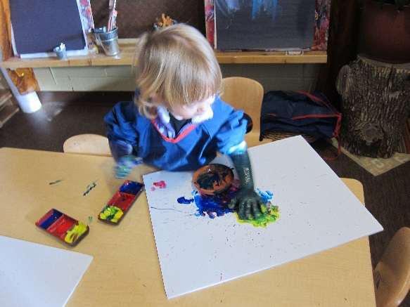
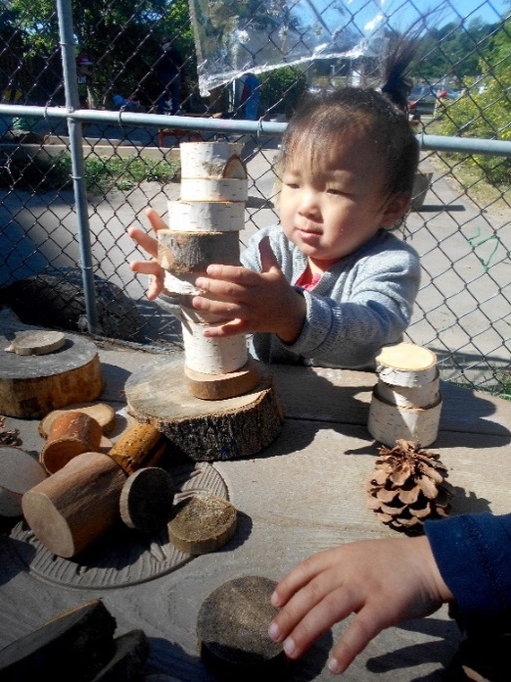

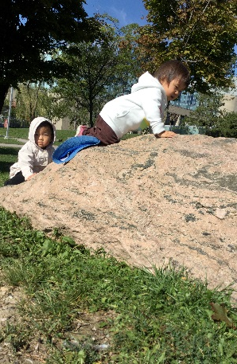

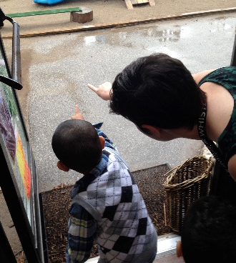

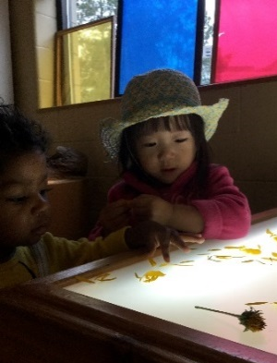
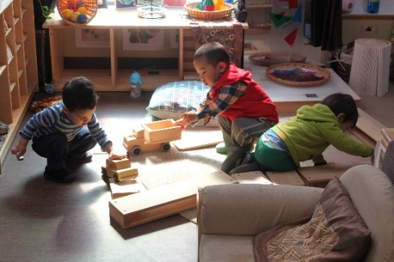

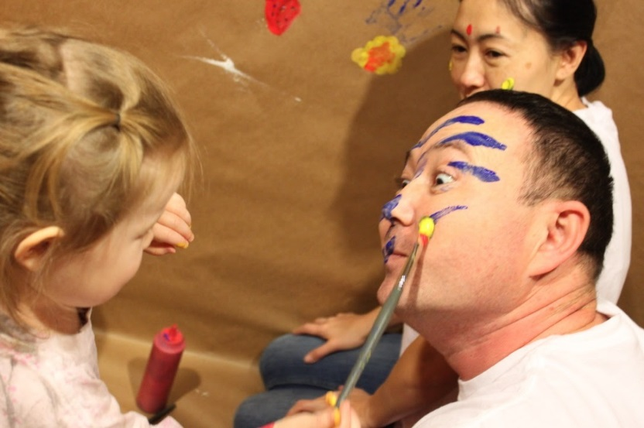
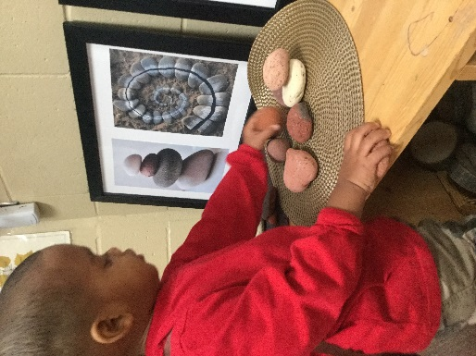
“…our image of the child is rich in potential, strong, powerful, competent and most of all, connected to adults and other children.”
-Loris Malaguzzi
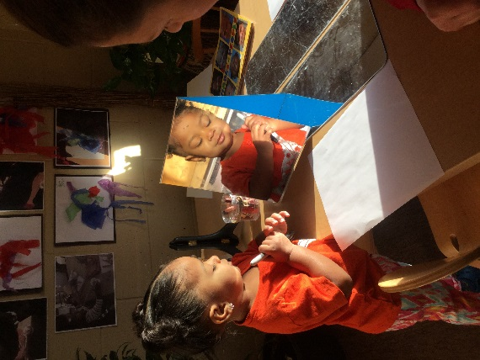
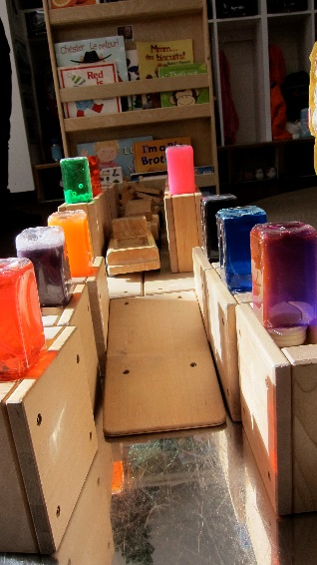
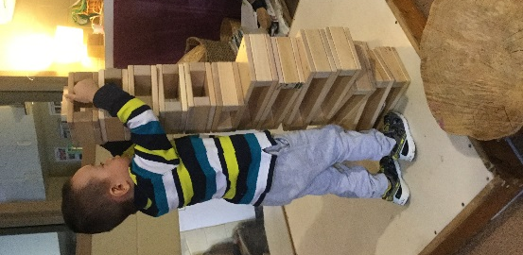
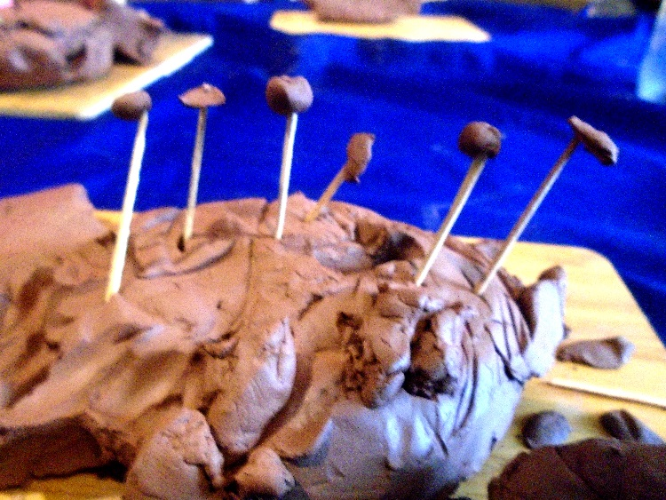
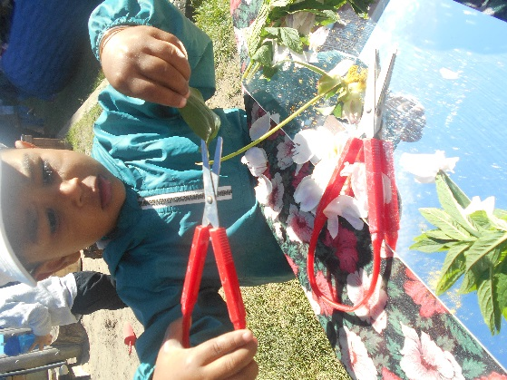
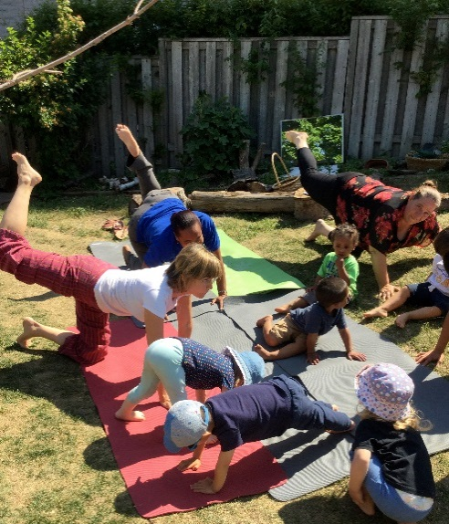
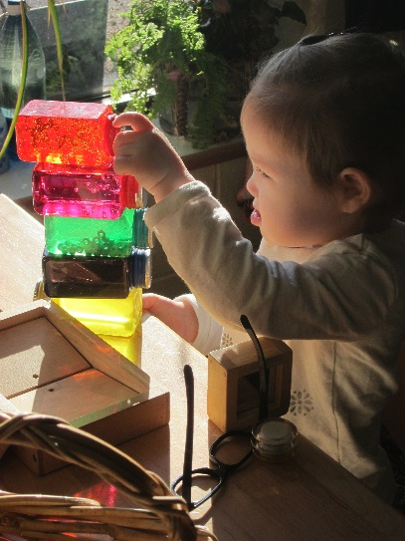
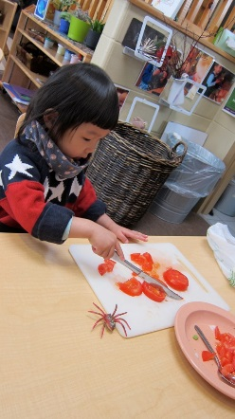
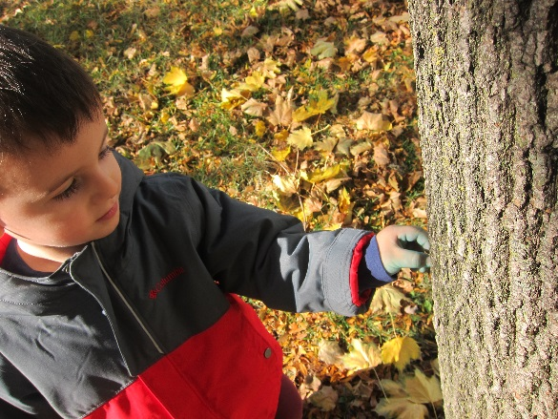
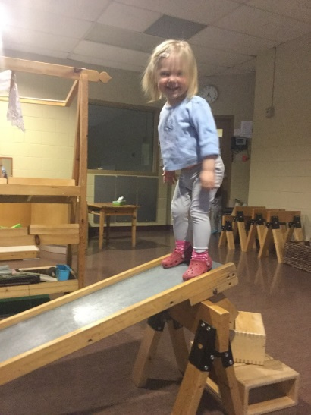

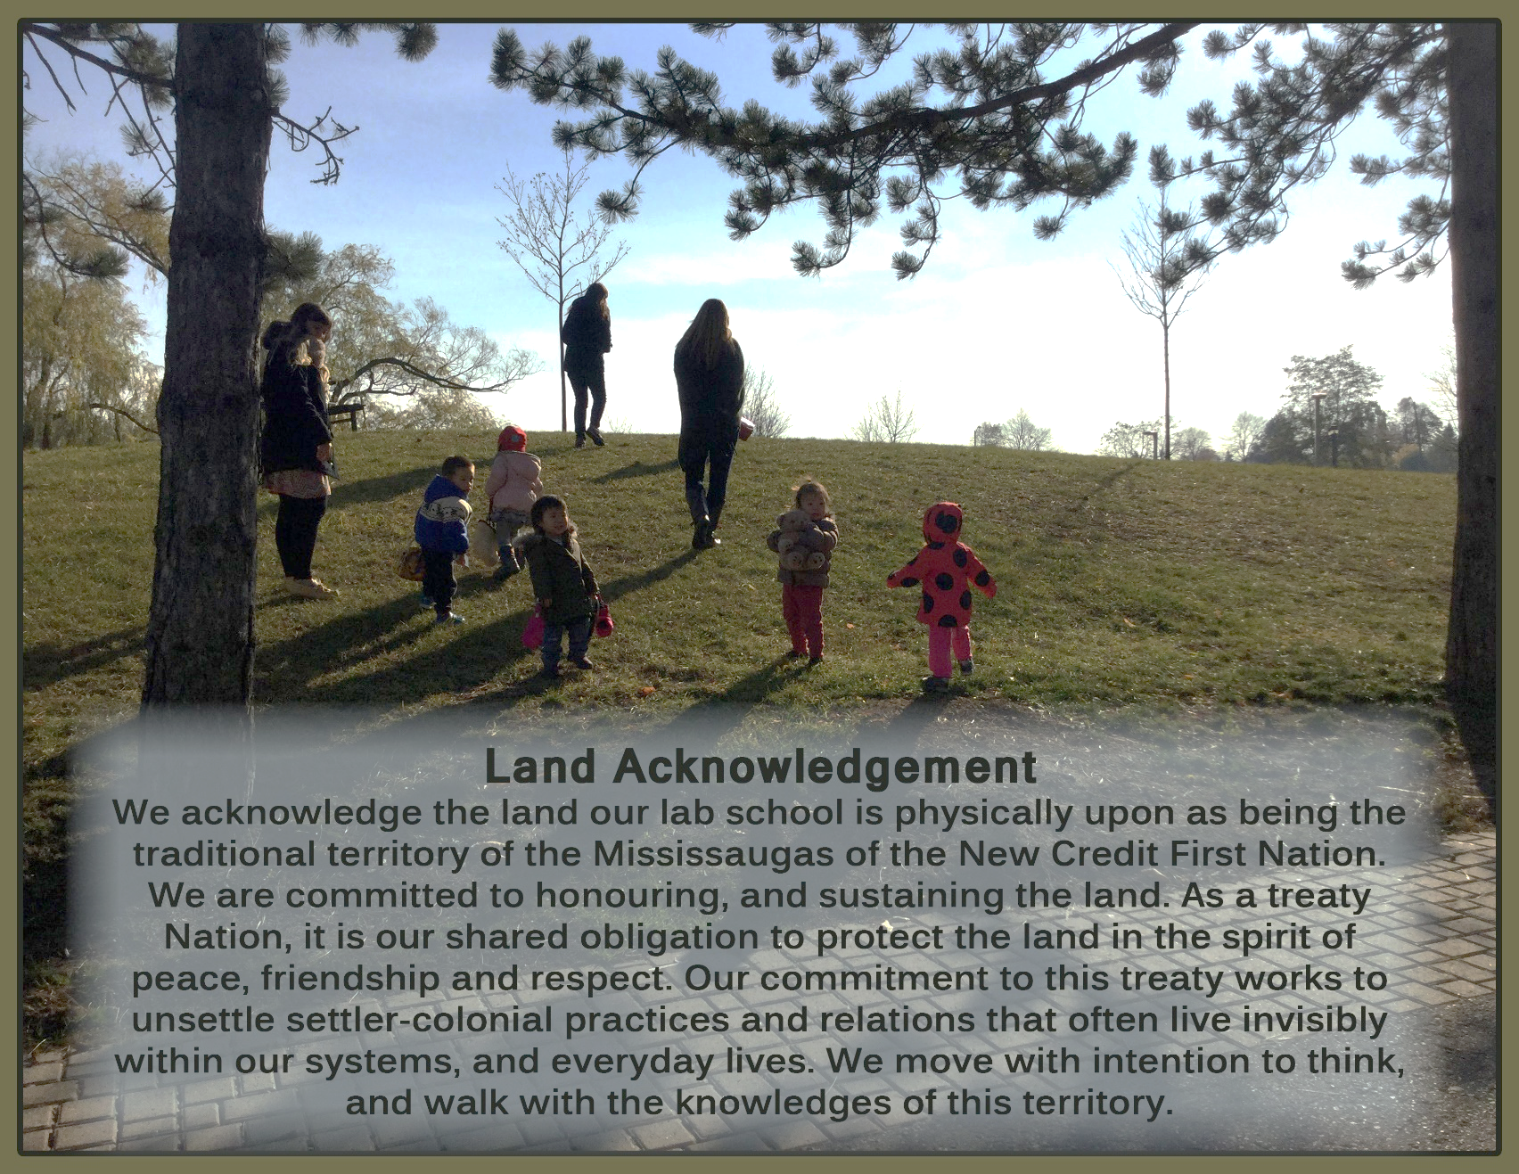

Welcome
Dear Families,
Welcome to the Lab School and a beautiful journey of learning. Families are an integral part of our successful child care program. Through family engagement and relationships we are better able to meet the developmental and personal needs of children. As child care professionals, we can serve as valuable resources for families and their children in areas of child development. You, the child's family serve as an expert in your child and we value your role and fully appreciate how the two must come together.
We believe that families and child care centres can and should work together to provide an environment that facilitates the growth of each child into a physically and emotionally healthy individual. We developed this booklet to help foster the relationship between the Lab School and our families. It provides you with specific information about the Lab School. In the pages that follow you will find our program statement, our policies and procedures, our goals for the children and our hope for a partnership with families.
I hope that you will find this booklet not only informative and helpful, but the beginning of an open conversation and dialogue. The ECE Lab School thrives to work closely with families, sharing with you the joy and wonder of your child's day and in providing the children with the benefits of high quality early learning and child care.
Thank you for choosing Seneca College ECE Lab School.
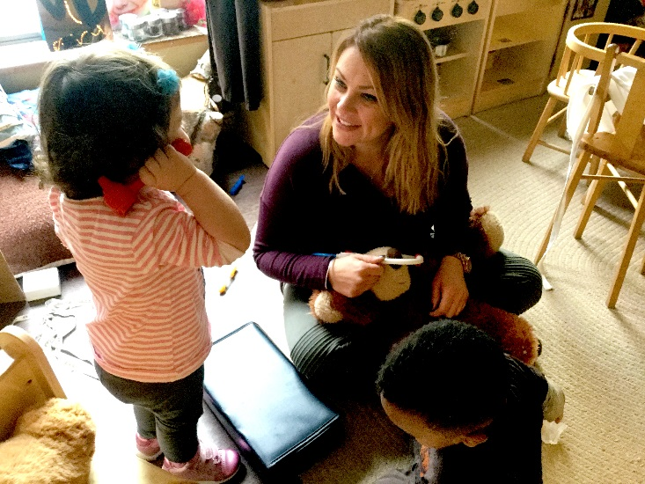
Tanya Farzaneh, RECE, MA
Manager ECE Lab School
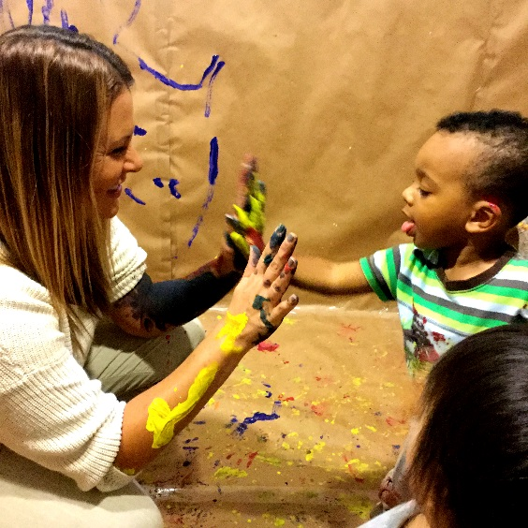
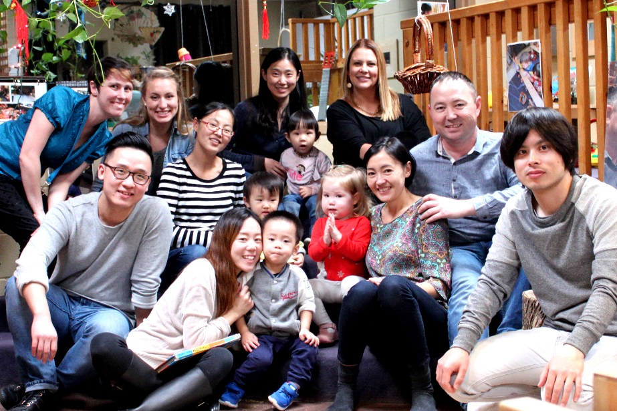
Table Of Contents
Table of Contents
Program Statement 6
We VALUE… the health, safety, nutrition and well-being of each child; 9
We VALUE… and support positive and responsive interactions among the children, families, and educators; 11
We VALUE…and involve local community partners and allow those partners to support the children, their families and staff; 15
We VALUE… and foster the engagement of ongoing communication with families about the program and their children; 15
We VALUE… documenting and reviewing the impact of the strategies set out in our program statement with children and their families; 19
We VALUE… and encourage the children to interact and communicate in a positive way and support their ability to self-regulate; 20
We VALUE… and foster the children’s exploration, play and inquiry; 21
We Value… planning and creating positive learning environments and experiences in which each child’s learning and development will be supported; 22
We VALUE…and provide child-initiated and adult-supported experiences; 23
We VALUE…and incorporate indoor and outdoor play, as well as active play, rest and quiet time into the day and give consideration to the individual needs of the children; 24
We VALUE…and support staff who interact with the children at the ECE Lab School in relation to continuous professional learning; 24
Policies and Procedures 28
Wait List Policy 28
Wait List Form 28
Request for Information 28
Offer of Space 29
Registration Fee 29
Deposit 29
Admission 29
Parking 30
Inclusion Policy 31
Prohibited Practices 32
Financial policy 33
Child Care Fees 33
Hours and Days of Operation 33
Unforeseen Closures 33
Employees/Educators 34
Orientation/Transition 35
Things Your Child May Need 36
Water Bottle 36
Dropping-Off & Picking–Up Your Child 37
Arrivals 37
Late Pick-Up of Children 40
Accidents & Emergencies 40
Student and Volunteer Supervision Policy 40
Confidentiality of Information 44
Observations, Photographs and Audio/Video Taping 44
Serious Occurrence Postings 44
Legal Obligation to Report Suspected Child Abuse 44
Medications and Illness 45
Any child with a medical condition that may require medication to be kept on site or needs accommodations must have an individualized medical plan document completed. These plans will be reviewed and updated annually or as needed. For more information please see the registration package or ask the Lab School Supervisor. 45
Medication Policy 45
Illness Reporting 45
Health Policy 46
Contagious Disease 46
Diarrhea 47
Rubella 47
Mumps 47
Impetigo 47
Hand-Foot-and-Mouth-Disease 47
Chicken Pox 47
Conjunctivitis (Pink Eye) 48
Fever 48
Vomiting 48
Food Allergies and Restrictions 48
Anaphylactic Policy 49
Strategy to Reduce Risk of Exposure 49
Food from Home 49
Birthdays and Celebrations 51
Family Issues and Concerns Policy and Procedures 52
Confidentiality 52
Conduct 52
Concerns about the Suspected Abuse or Neglect of a child 52
Withdrawal Policy 3
Code of Conduct: Belonging, Engagement, Expression and Well-Being 4
Phone Numbers and Contact Information 6

“Learning and teaching should not stand on opposite banks and just watch
the river flow by; instead, they should embark together on a journey down the water.
Through an active, reciprocal exchange, teaching can strengthen learning how to learn.”
-Loris Malaguzzi (Hundred Languages of Children 1993)

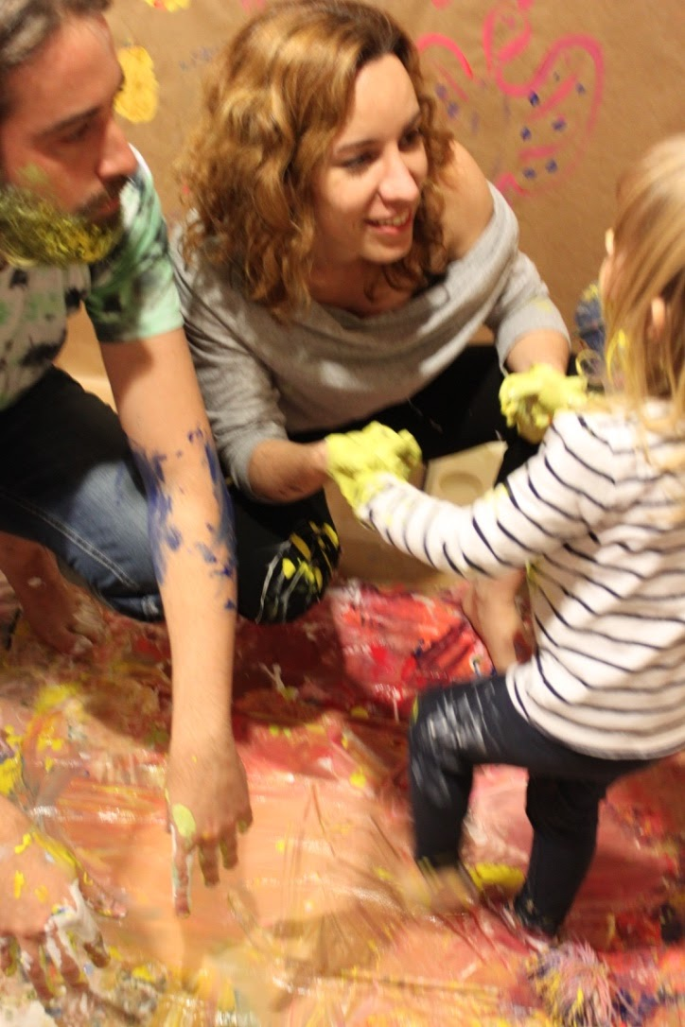
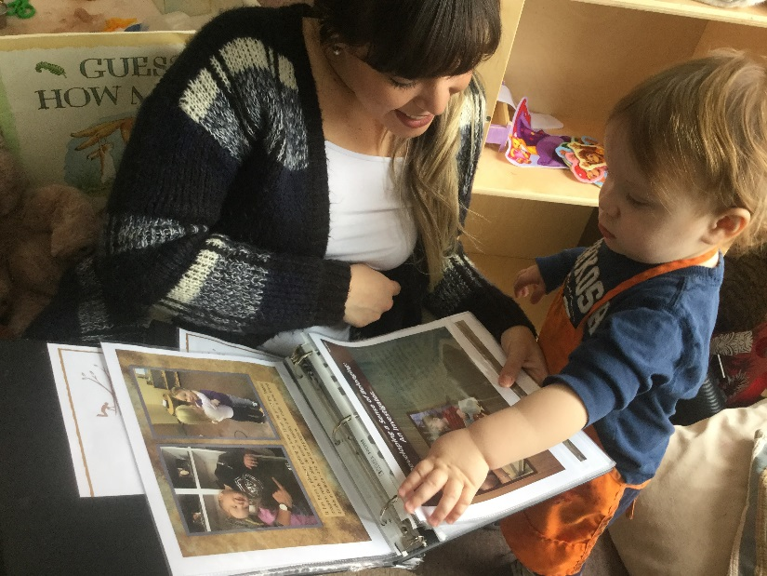
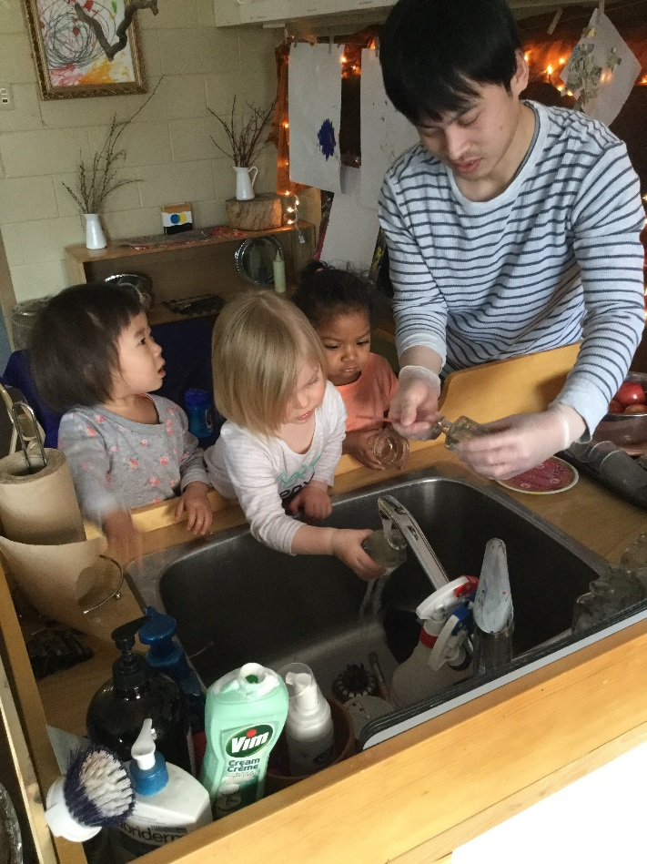

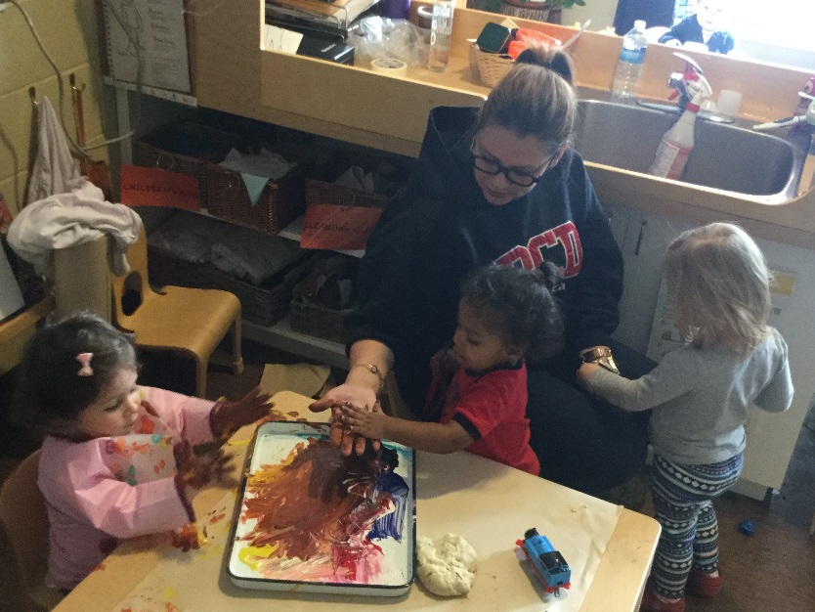

Program Statement
The Seneca College Early Childhood Education Observation Laboratory Teaching School (ECE Lab School) is a demonstration and observation centre for the School of Early Childhood Education Diploma Program, ECE Apprenticeship Diploma Program, and Bachelor of Child Development Degree Program. The ECE Lab School opened its doors in 1969 two years after the ECE Program began at Seneca College. In 1992 the Lab School moved to its permanent site at the Newnham Campus. The program provides care for Toddlers, and Preschoolers.
The ECE Lab School is a lab facility for the ECE students at Newnham Campus. Serving as a primary field placement experience, we model the program, curriculum and guidance methods the ECE students study in the classroom. There are usually students on placement daily at the Lab School. Each ECE student is assigned to one staff member.
Seneca ECE Lab School has explored a variety of pedagogical approaches related to the field of early learning over the last several decades. We have been committed to professional learning, reflective practice and building a shared community, where all members are free to pursue interests and the holistic development of themselves in relation to others. Seneca College has a mandate to always strive to be up-to-date with the latest early learning trends and research. The Lab School uses current theories to support curriculum planning and environmental design. We are inspired by the philosophical approaches of Loris Malaguzzi and the guiding principles of the pre-primary schools in Reggio Emilia, also known as the Reggio approach. At the ECE Lab School, we advocate and are inspired by nature and the benefits of being connected with an environment that honors children as capable and confident learners. We have a strong view of the child as a protagonist in their own learning. When the environment acts as the third teacher, the children can become researchers and builders of theories who initiate their learning experiences through the exploration and investigation of quality materials.
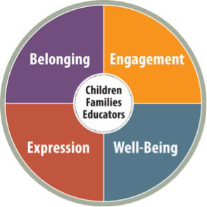
Seneca ECE Lab School is committed to high quality care. In this, we have a consistent pedagogical approach that aligns Ontario’s Vision for quality in the Early Years. “How Does Learning Happen? Ontario’s Pedagogy for the Early Years (HDLH, 2014), a guide which builds on government initiatives and supports the ‘Framework for Ontario Early Childhood Settings: Early Learning for Every Child Today’ (ELECT; Ministry of Education, 2014); which describes how young children learn and develop, and provides a guide for curriculum in Ontario’s Early Childhood Education settings. HDLH is set around four foundations of learning to support educators in building a shared vision for education in the early years.

Belonging, Well-being, Engagement and Expression are centered on the child and their relationships to family, educators and the environment. Educators at the ECE Lab School have a shared vision of these foundations alongside the image of the child, educator and family. We are partners in children’s learning, sharing and respecting the valid role each plays in this process.

The four foundations outlined in HDLH are embedded and intertwined throughout our beliefs, values and philosophies of teaching as demonstrated in our pedagogical practices and daily interactions. For the foundations to truly merge and materialize in an authentic and meaningful ways; all of the components need to be valued together. We see connections that are complimentary and support one another, and ensure to interconnect all of these foundations and we don’t compartmentalize each one. They are all connected and each one enhances the other.
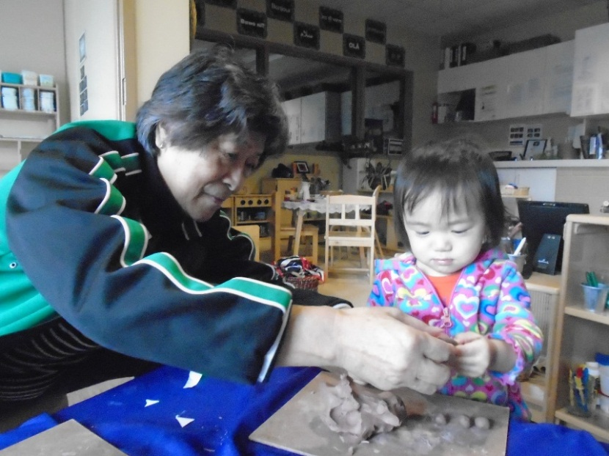
The Lab School is committed to building, facilitating and encouraging healthy, positive and responsive relationships within our community. This includes children, employees/educators, families, student teachers, faculty, outside agencies and professional communities of practice. We believe that these relationships begin with respect and communication. Each person at the ECE Lab School is valued and considered part of the community. Educators commit to developing a relationship with each child and to understand each child’s unique way of expressing, communicating and learning. We value and actively take part in building relationships through ongoing communication. We believe in the value of listening to the hundred languages of children.

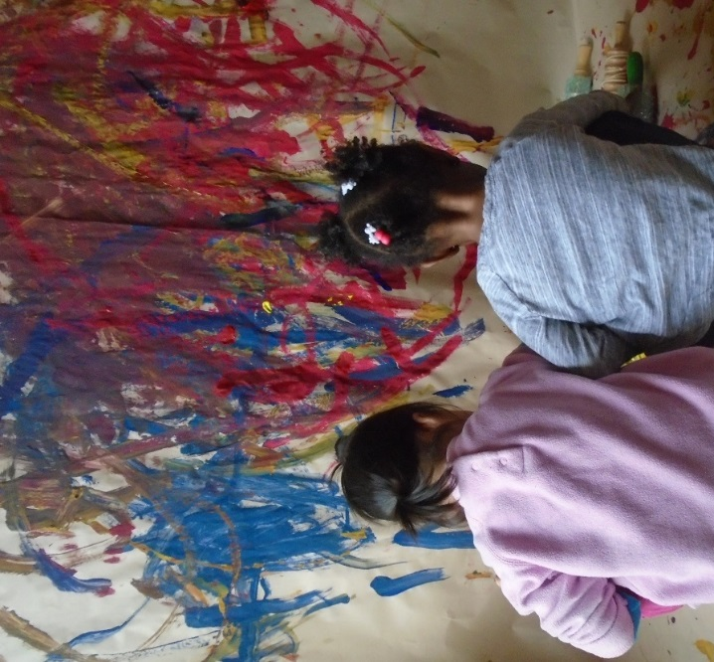
“The hundred languages are the endless number of children’s potentials, their ability to wonder and to inquire.
The hundred languages remind us that there are multiple ways of seeing and multiple ways of being.”
-Reggio Children
Each child is viewed as an individual with unique gifts, talents and expressions of their inner self. We work to observe the children in deeper ways, trying to understand them and how they come to know and understand their world; trying to interpret the spirit of the child.
In this act of listening, we strengthen our understanding of the children and deepen our relationship with them, their families, ourselves and each other. This validates their language(s) in our community.

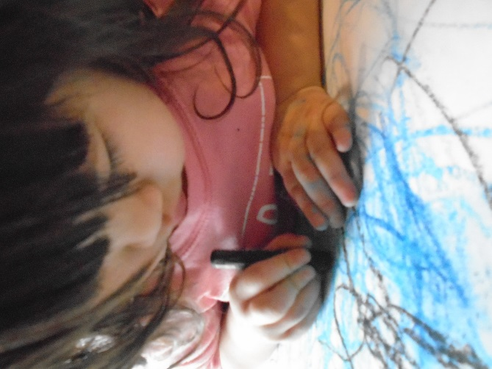
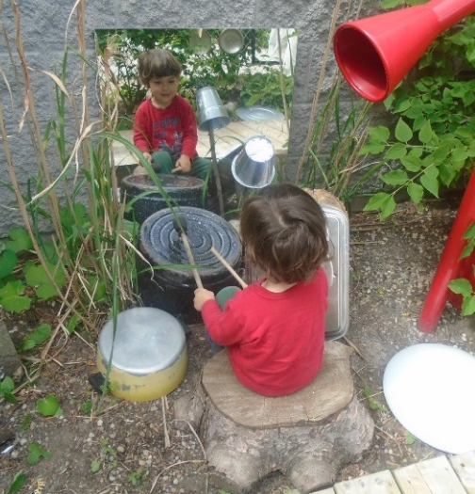
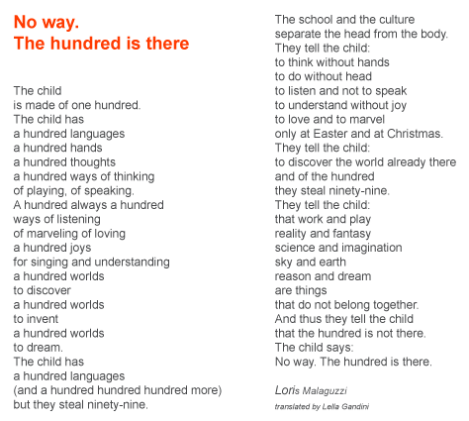

We VALUE… the health, safety, nutrition and well-being of each child;
Seneca ECE Lab School is committed to supporting the health, well-being and safety of all. Daily opportunities are provided that support children in developing self-help, self-care and self-regulation skills. Building on our view of the competent child, children are encouraged daily to take interest in self-care such as feeding, clothing and toileting needs with the support of an adult. This encourages children’s developing autonomy, sense of self, and supports emerging skills. The environment both indoors and outdoors, offers children safe, yet reasonably challenging opportunities to assess risks and challenges as per their emerging capabilities.
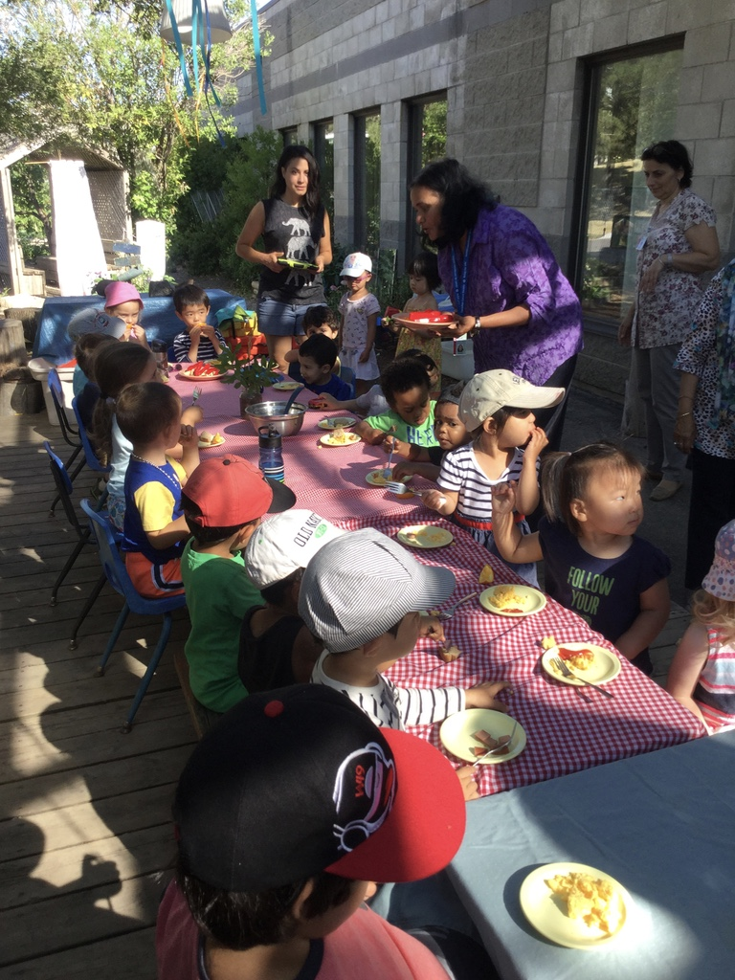
Children are viewed as active members of the classrooms, contributing to the maintenance of the indoor and outdoor environments. Children exercise choice in healthy meals available. An open snack and family style lunch, encourages children to listen to their unique rhythms and to determine the amount of time and food theirs bodies need.
Diverse multicultural meals enrich our understanding of others and celebrate our uniqueness and similarities together. The ECE Lab School provides balanced lunch and snacks based on Canada’s Food Guide. Our morning snack is catered and children will participate in the creation and delivery of snack occasionally. Milk and water are available at snack and lunch, while water is available to drink throughout the day. The educator handling food preparation and distribution has a Food Handlers Certificate. We are a nut-free center and allergies and food restrictions are posted in the kitchen as well as all classrooms. Families are asked if they bring food for their child, to store it in the fridge with the date and the child’s name clearly marked on the outside of the container.
To ensure the safety of all children, the ECE Lab School adheres to a regulated sign-in and sign-out policy. Upon arrival and at pickup, children are signed in and out by an educator. Attendance verification is documented verbally as well as in writing throughout the day, during transitions and rest periods. Families are responsible to ensure an educator is aware of the arrival and departure of their child. Early Childhood Education (ECE) placement students are involved in a mentoring relationship with educators and will not be left alone unsupervised with children at any time. This includes times of a child’s arrival and departure.

Early Childhood Educators (Full-time & Part-time) at the Lab School are Registered Early Childhood Educators (RECE) licensed by the College of Early Childhood Educators. The ECE Lab School also employs and mentors Child Development Practitioners (Apprenticeship) and 4th semester ECE students working towards qualifications to work alongside RECE’s.

All employees are trained in health and safety protocols and follow the Ministry of Health and Safety guidelines. Hand washing procedures are modelled and supported. Additionally, sanitation procedures and daily disinfecting records are outlined and posted in each of the classrooms. Staff and students work together to maintain a clean, healthy and safe environment for the children. Beds and linens are disinfected weekly or as needed. Children’s personal bedding is sent home on Fridays to be washed and returned to school the following week. We are cognizant and try to eliminate environmental and other potential hazards within our environment. The ECE Lab School is environmentally conscious in reducing waste and reusing materials in a sustainable manner.
Toileting and diapering routines follow Toronto Public Health protocol. Educators at the Lab School view diapering and toileting routines as opportunities to build relationships and connections with children. These routines, as well as others, are viewed as valuable learning opportunities within the curriculum, building relationships and supporting the overall development of the child. Opportunities to enhance language, social, and self-help skills are embedded throughout these routines. All interactions throughout the day are considered part of the curriculum and further develop our pedagogy. A strong focus on personal and authentic relationships is our goal.
Good hygiene habits are strongly emphasized and all employees and children are required to wash their hands upon entering the room, after toileting, before and after sensory play, and before participating in snack and lunch time routines. Handwashing protocol is monitored by the Lab School Manager regularly.
Educators and ECE students are trained in Standard First Aid, including Infant and Child CPR upon hire, prior to field placement and/or prior to expiry. Educators and ECE students also participate in anaphylactic training including the proper use of Epi-pens each year and upon enrollment of a child who has an Epi-pen. Workplace Hazardous Materials Information System (WHMIS) training is attend by all Lab School employees.
The outdoor environment receives a basic inspection twice daily by ECE Lab School employees and a more in-depth inspection monthly by employees and annually by a 3rd party, to ensure they meet all safety and maintenance requirements. The ECE Lab School conducts evacuation and fire drills on a monthly basis. A safe shelter location at Seneca Hill Public School is available in the event that a college-wide evacuation is required and families will be notified by phone.
The ECE Lab School collects information from each employee, child and ECE student, including documentation of immunization. In accordance with the Child Care and Early Years Act, Section 35 (1) of O. Reg. 137/2015 a child who attends child care should be immunized prior to admittance and as needed according to Ontario's Immunization Schedule. Each employee at the ECE Lab School must provide a medial health assessment and be up to date with their immunizations as recommended by Toronto Public Health. As part of routine practices, child care center operators and employees must continually assess the risk of exposure to bodily fluids and excretions, identify strategies that will decrease these risks and prevent the transmission of microorganisms that can cause disease. Reducing or removing the risk of disease transmission is incorporated into the culture of the facility.
Educators will review each child’s registration information prior to enrollment to better understand their eating, sleeping and play preferences; noting allergies, and food restrictions. The health of each child is paramount and documented on a daily basis.
Our medication policy requires that medication be kept in a locked medicine box, out of children’s reach. Refrigerated medication must be stored in the lock box located in the fridge and non-refrigerated medications must be locked in the lockbox in the cupboard in the kitchen. All medications must display a pharmaceutical label with the child’s name on it. A medication log is kept for each child requiring medication which families must sign and specify the medication, dose, and time to be administered and it must match the pharmaceutical label. Only an RECE will administer prescription medications and they will sign the log when the dose has been administered and have families sign-off upon completion. Epi-pens and inhalers will be kept in each program’s emergency bag which will accompany the child at all times.
ECE Lab School employees will comply with the regulations and procedures set out by Seneca College, the Child Care and Early Years Act 2014 (CCEYA), Occupational Health and Safety Act, the Ontario Fire Code and all other applicable Federal, Provincial and Municipal Acts and Regulations which apply to this institution. A number of agencies provide support and guidance to the Lab School; including but not limited to: City of Toronto Children’s Services, Ministry of Education, Public Health Units, Ministry of Health and Long Term Care and Adventure Place.
We know that the first step in establishing and nurturing the health, safety and well-being for children and their families is through the relationships and connections we form, cultivate and sustain.

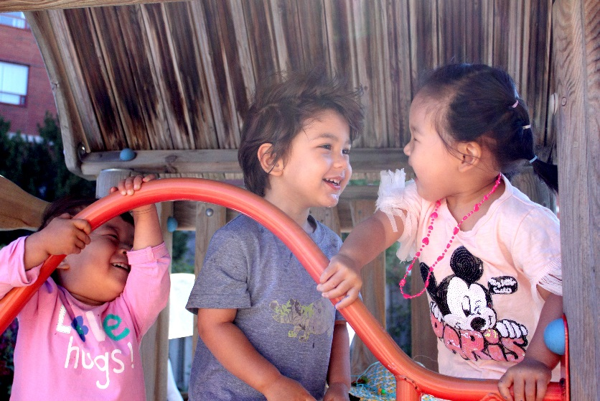
We VALUE… and support positive and responsive interactions among the children, families, and educators;
We hold a strong image of the child; rich, capable and full of potential. The ECE Lab School values the holistic development of each child; creating a foundation where children are citizens and able to form their own community. Educators promote discussion, guide and encourage children to listen to each other’s verbal and non-verbal language and expression. This pedagogical teaching practice has fostered various forms of engagement and expression. Children prove to be resourceful, creative, competent and true problem solvers. They are natural explorers, inquisitive; and through play we believe the child has a hundred ways of knowing, of expressing, and learning.
Building on the foundations of belonging and deep engagement, we see children as citizens with rights, holding the power to express their own ideas and desires. They are free to truly express themselves through all of their hundred languages. We believe in children’s capabilities and in their power to guide the learning process.

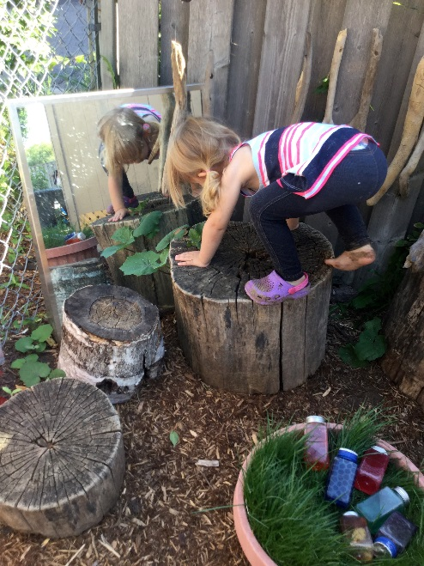
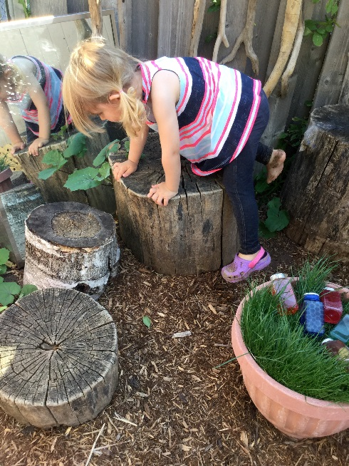
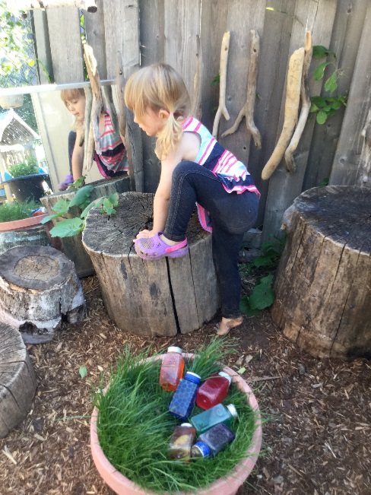
The Capable Child: “…discovering not so much the limits and weaknesses of children but rather their surprising and extraordinary strengths and capabilities linked with an inexhaustible need for expression and realization.” -Loris Malaguzzi
Children have rights, can assert autonomy, have the right to be heard and to be a part of the decision making process in the classroom. Children are empowered to embrace their rights as active citizens in our community.
Educators unite all facets of pedagogy and learning into one; each component dependent upon the other. This enables us to listen to more than a part of a child, but rather the whole child. This is how learning happens. The child is more than the sum of their parts. This is our foundation of the view of the child.
“Children need a great deal of freedom: the freedom to investigate and to try, to make mistakes and to correct mistakes, to choose where and with whom to invest their curiosity, intelligence, and emotions. Children need the freedom to appreciate the infinite resources of their hands, their eyes, and their ears, the resources of forms, materials, sounds and colors. They need the freedom to realize how reason, thought, and imagination can create continuous interweaving’s of things and can move and shake the world."
-Loris Malaguzzi, Reggio Emilia
Our image of the educator has evolved over time. It moves away from a traditional role of information provider, expert or rule keeper to one of co-creator/learner with children. We hold a strong image of the educator, rich, capable, full of potential, a co-learner, and guide with others. A facilitator of the learning process, as educators, we must learn to listen in a hundred ways. Embracing a passion of lifelong learning, we engage in daily self-reflective practice.
“Children are most likely to engage in long, complex episodes of play and demonstrate interest in learning when educators value their ideas and contributions to the curriculum. Children’s engagement and learning are enhanced when educators are co-learners” (HDLH .p37).
The educator’s role is to establish an environment cohesive to this learning. Working with children in a mutual respectful way as partners, co-creators and supporting children in their interest; a process of discovery, inquiry and learning, for all. A child standing on top of a chair to engage in a more substantiated relationship with clay is not ‘breaking the rules’, but rather developing a deeper relationship with the material. Reflecting on children as citizens with rights, enables us to broaden our understanding of our relationship with them. Listening and interpreting children’s voices provides the opportunity to become co-creators of their play.
Of equal importance is the bond educators cultivate with families affirms that we make relationships a priority; communicating effectively and providing support which builds a strong foundation of trust. Our goal is to create a sense of belonging, engagement, expression and well-being with all families. They, in turn become part of the program, adding and enriching learning for all.
We hold a strong image of the family as a contributing member of our community; the first and most important educator of the child. Strong, rich, capable and full of potential. A co-learner and partner, sharing in the process and journey of learning. Families offer knowledge and a unique perspective of their child. We embrace working collaboratively with and supporting families. “Fostering good relationships with children and their families is the single most important priority for educators in early year’s programs” (HDLH, P.24.) Our community would not be complete if families did not share a sense of belonging. As a team, we continuously try to develop authentic relationships with the families, generate common goals and rejoice in their children and their achievements.
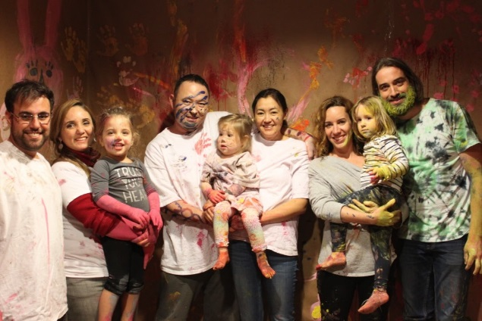
Educators encourage families’ presence, participation and engagement within the classroom through many modes. Sharing the strength of each individual family guides all facets of the program and encourages and participation. Families have shared talents through things like building a mud kitchen with pallets, cooking diverse cultural dishes to bringing a sense of ‘home-like’ atmosphere to the center.

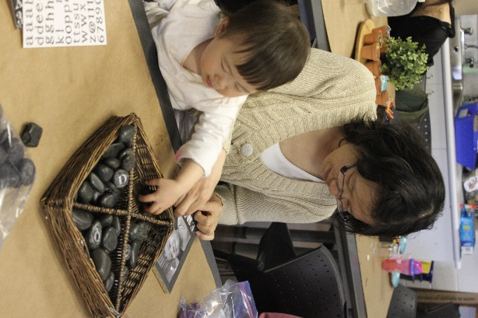
Opportunities to strengthen relationships are offered throughout the year through events such as; exploring a museum on a weekend, creating resources through workshops such as ‘Pinterest comes to Life’, creative art engagements, and parenting workshops. The ECE Lab School has an ‘open-door’ policy with families. By welcoming and encouraging families’ presence in our programs, we are conveying to families that they are valued and important and that they have a voice in all areas of their child’s daily learning.
Families are encouraged to share their culture through sharing music, art, cultural clothing and other artifacts. ‘Family engagement’ is not about giving families’ information, but rather an opportunity to build, connect and strengthen relationships with each family and ultimately each child.
Educators share philosophical and pedagogical beliefs as well as current research trends with families, who are encouraged to reciprocate, through sharing their experiences, values and beliefs, culture and their own research. This lends itself to reciprocity; a deepening relationship for all. This relationship continues to endure even after each child continues their journey outside the classroom. Families continue to share and rejoice in their child’s new experiences and milestones and demonstrate an interest in listening and sharing, playing and learning, giving and taking.
Our programs are richer and each child’s journey is enhanced through the deep relationships we strive to have with all of the families in our ECE Lab School community.
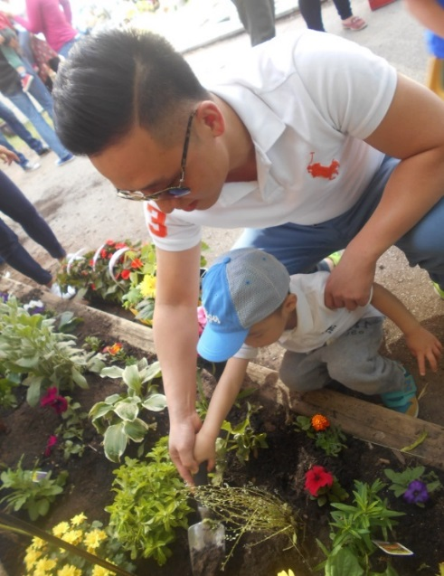
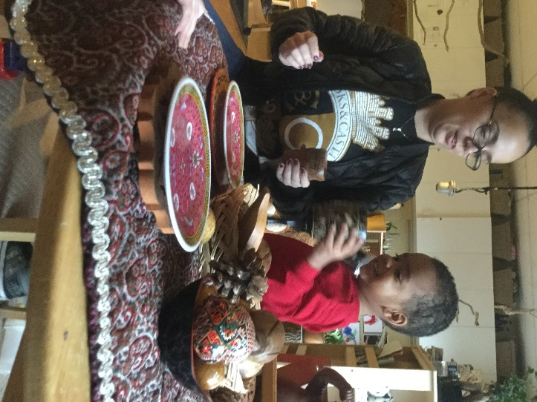

We VALUE…and involve local community partners and allow those partners to support the children, their families and staff;

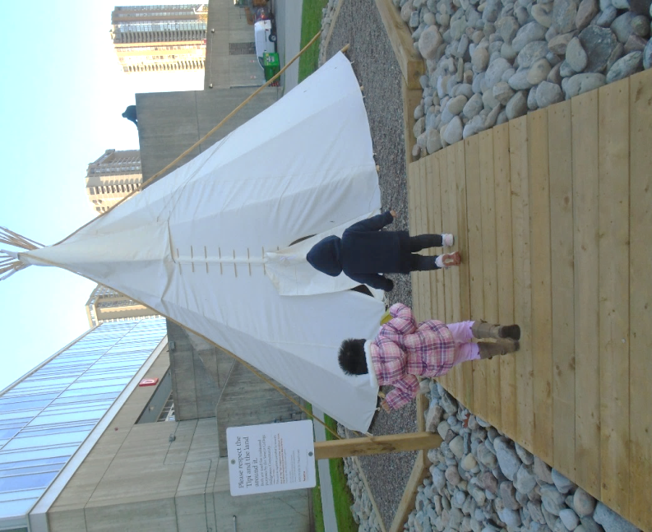
As part of the greater Seneca College community, we investigate various ways we can further enrich children’s lives through our many partners. Educators introduce the teachings of Indigenous Knowledge’s with a strong relationship with the First people at Seneca and attending various traditional ceremonies. Children participate in activities hosted by the Seneca Fire Protection Program students, explore and investigate nature at Seneca’s King Campus, participate in the Remembrance Day Ceremonies and in our traditional yearly celebrations with the Confucius Institute.
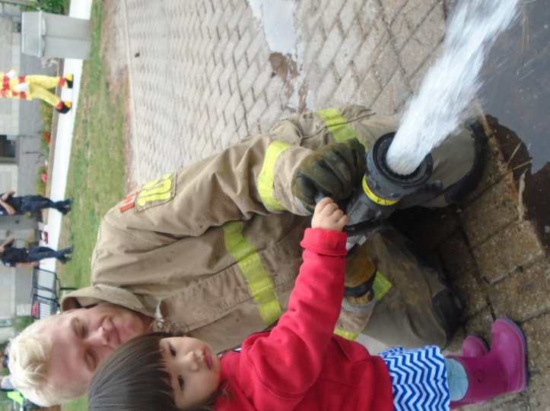
The children have developed a relationship with the greater Seneca community based on these program extensions and have come to meet and know many employees within this space. The strength of community lies in the strength of the connections that we have with each other. With strong connections, we have the power to make real change, and a difference.
The ECE Lab School embraces diversity and family culture; enriching the environment and lives of others. Our goal is to provide an interconnection through diverse cultures. Educators share and incorporate many global languages; welcoming signs, documentation, quotes and labels in the classroom are evidence of shared enriched languages. Families and ECE placement student are encouraged to help present their culture and enrich children’s curriculum through food, cultural dishware, artifacts, picture books and art. We continually search for ways to include families and create an environment that celebrates and supports our Canadian diversity.

We VALUE… and foster the engagement of ongoing communication with families about the program and their children;
Communication is a reciprocal process between families and educators. It is not just merely the transmission of knowledge through these encounters, but getting know and understand each other on a deeper level. This is achieved through building a relationship and creating a culture of caring and respect in our community.
Effective communication is vital to the ECE Lab School’s success. A key form is the family orientation handbook and the registration package that families share upon enrollment. While the family orientation handbook communicates our ECE Lab School culture to the families, the registration package provides an opportunity for families to share information of their culture, holidays they celebrate, views, values, languages spoken and more. Families are encouraged to let us know their preferred language so we can provide printed materials in their preferred language and find ways to incorporate the language into our classroom communities as well. Families will also receive a program handbook from their programs educator for their specific classroom.
Communication is always most successful when it is between the people who are directly involved in the situation.
Suggested guidelines to follow of who to contact:
Child’s Educator concerning:
- materials your child needs for the classroom (ie. Diapers, clothing etc)
- changes to or events happening at home
- information about child development
- community partners
- contributions to the program
- information about your child’s day
Lab School manager concerning:
- Request private meetings with educators and/or Lab School Manager (Families can also request a translator be present if needed.)
- Parking pass, key cards, etc.
- Fees and payments
- Any issues unable to be resolved
Educators will also communicate with families in a variety of forms which may include, but are not limited to:
- Daily discussions at drop-off or pick-up, daily intake forms in the toddler programs and lunch/sleep charts in the preschool programs. Occasionally, educators may contact families via phone or email to give them an update on their child’s day. Additionally, families are invited to read the daily Program Plan to gain insight into the variety of encounters with learning the children had throughout the day.
- Emails may also be sent on occasion to share photos of your child’s joy and wonder of learning.
- Family engagement gatherings may include opportunities to get to know the other families and educators within our community, to share in discussion and documentation of your child’s learning and experiences and to have the opportunity to play and mess about with the children. Events include Nature Play Day, our Annual Holiday Party, Family Evenings for each classroom, Paint Nights, Weekend Filed Trips, etc.
Printed materials families receive may include:
- Newsletters
- Articles of interest
- Accident/illness reports
- Invitations to events
- Developmental screenings
- Family resource information on a variety of topics
- Accident reports
Families that share parenting/ custody can inform the lab school manager and request two copies of printed materials to be sent home for both parents.

Portfolios/Documentation
Educators place value on children’s portfolios which provide a lens of children’s learning. This reflective tool includes learning stories, episodes of play and discovery, creative art representations, family voices, developmental milestones and assessments. The biographies transcribe children’s voices, thoughts, theories, and learning that represent a true holistic image of the child, culture and community.
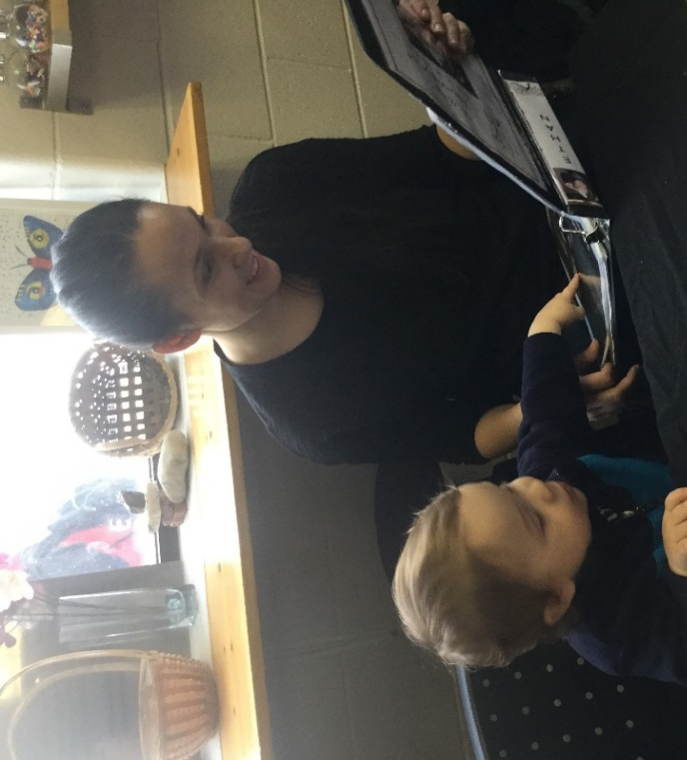
Families are encouraged to share their voices by writing their thoughts, feelings and experiences of a project, episode or story about their child. These stories enrich documentation and child’s portfolios. This method of communication has resonated with the educators at the ECE Lab School and its many visitors; adding to and enlightening children’s learning and helping to disseminate their child’s thinking. We have all come to value these voices; providing educators with the insight that families are partners in their child’s early learning, they too know, and appreciate that their child’s voice is understood, heard and valued.

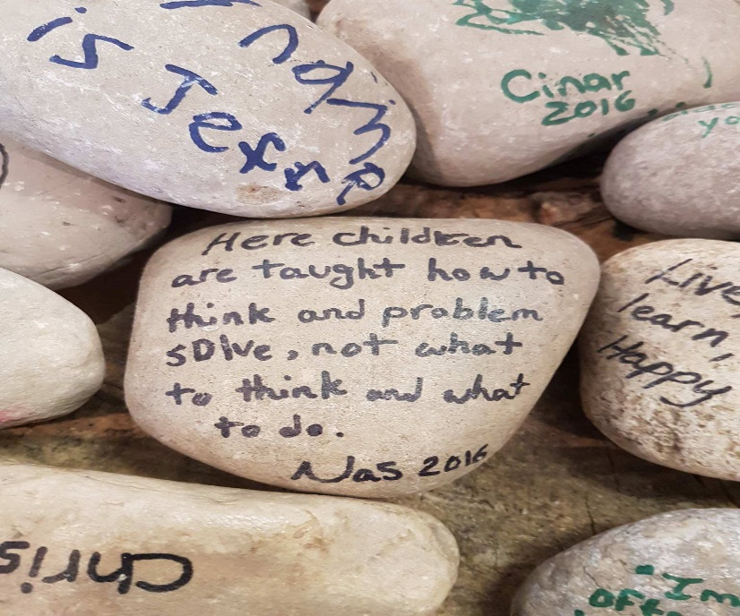
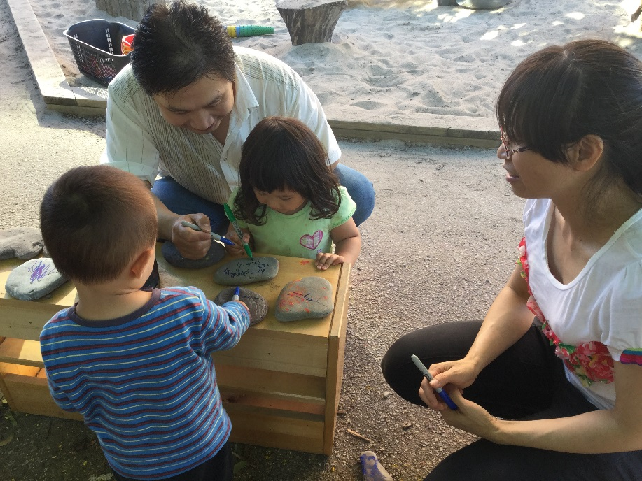

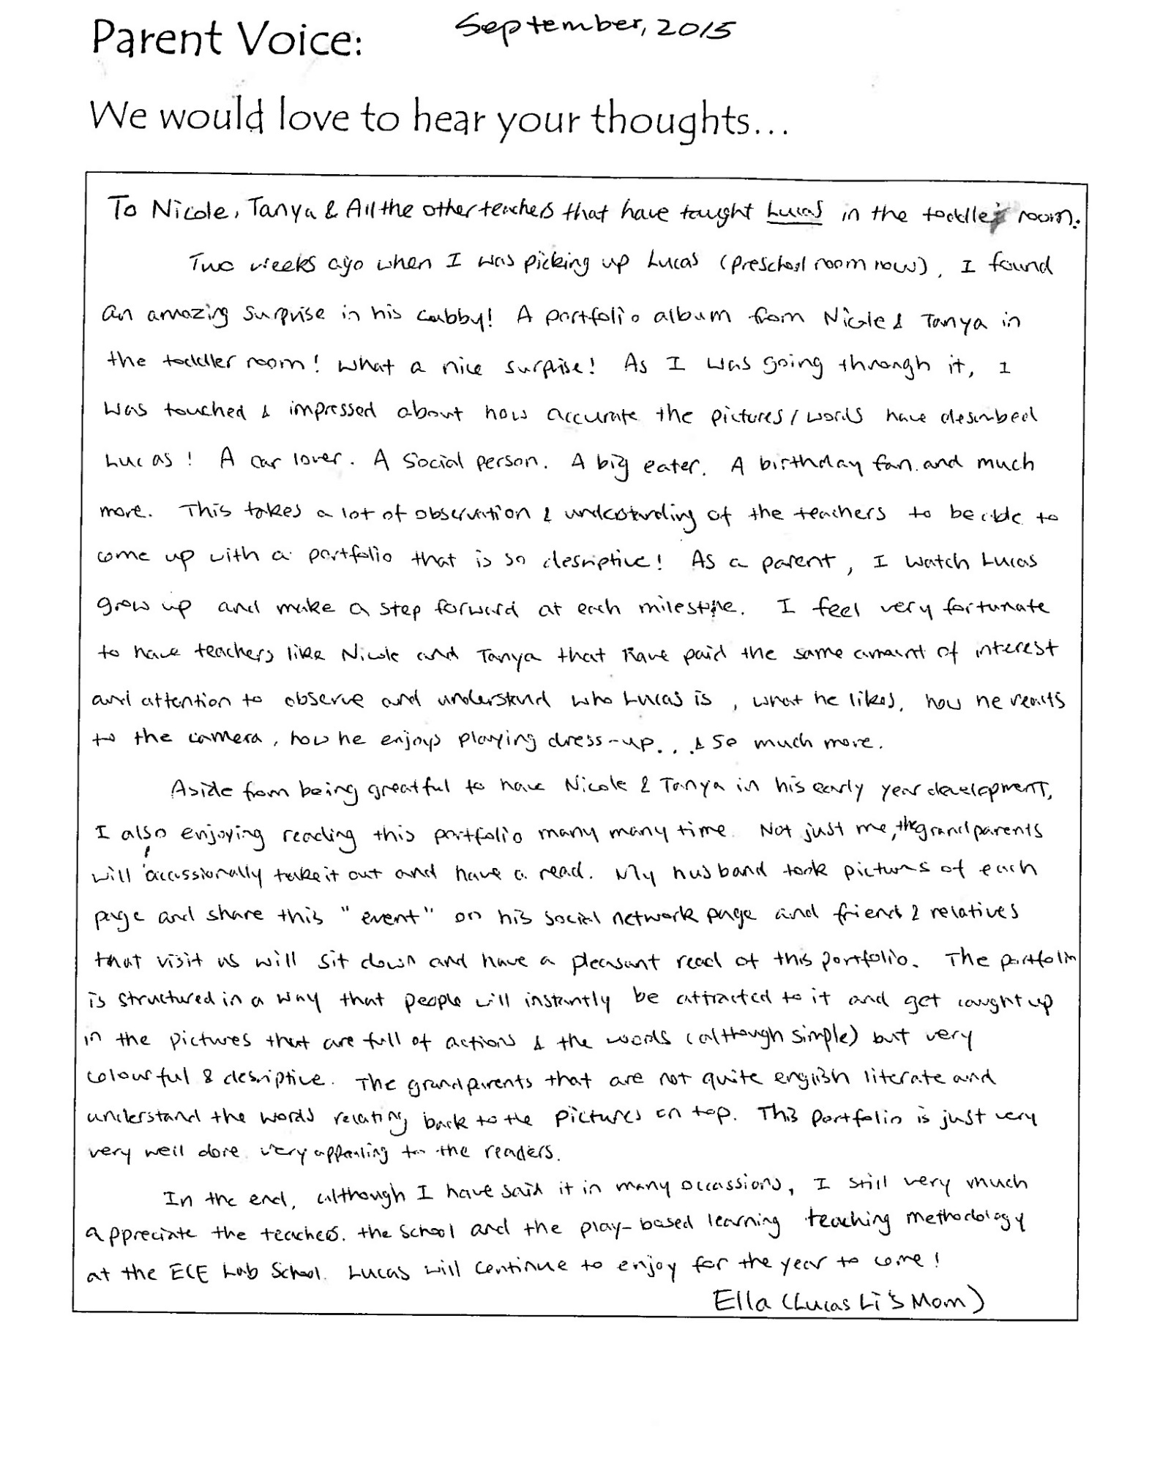

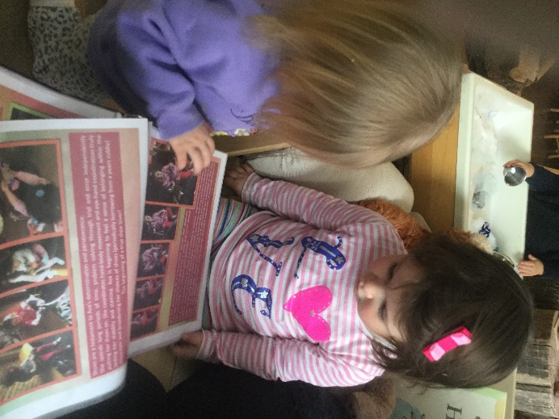
We VALUE… documenting and reviewing the impact of the strategies set out in our program statement with children and their families;
The children’s portfolio is considered a living document continually evolving; a beautiful tribute to their learning. Through these living documents, educators at the ECE Lab School are able to highlight the seeds of knowledge they have helped to plant, setting the foundation for the children as lifelong learners. These portfolios not only capture the children’s development and learning, but also document the impact of the strategies set out in our program statement; showing how these values and views become the roots for the children to grow into being active and confident citizens in the greater community beyond the walls of the ECE Lab School.
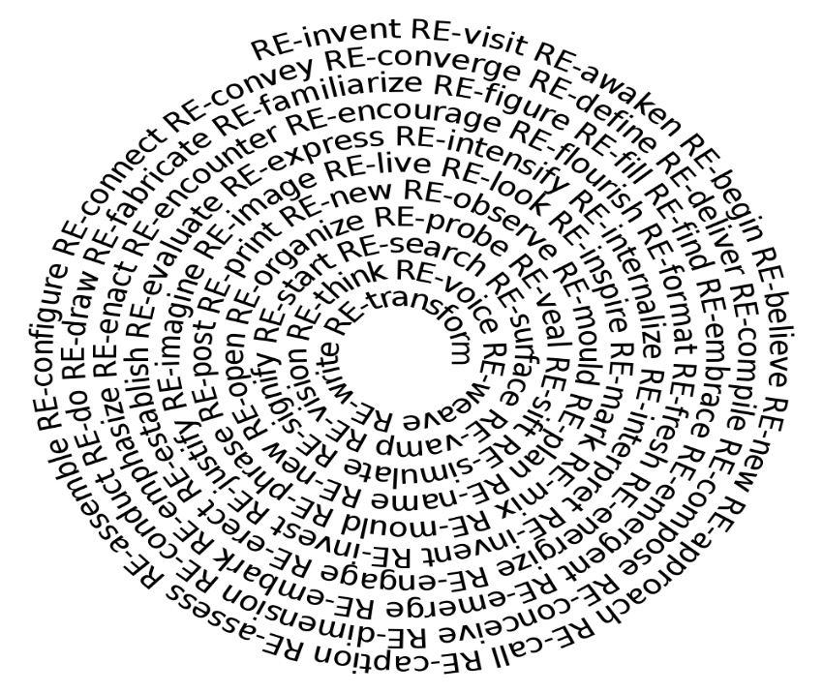
Rich pedagogical documentation is created and displayed eloquently, giving thought to the audience albeit children, families, colleagues, early childhood practitioners or early childhood education students. Pedagogical documentation is a tool for educators to engage in reflective practice as well as to reflect on children’s learning which supports future curriculum development. Through the process of creating this documentation and the reflection process, our views, pedagogy and core foundations grow and change. This then becomes reflected in our program statement as it evolves and changes along with us on this journey of discovery.
RE-Discover Your Way!

We VALUE… and encourage the children to interact and communicate in a positive way and support their ability to self-regulate;
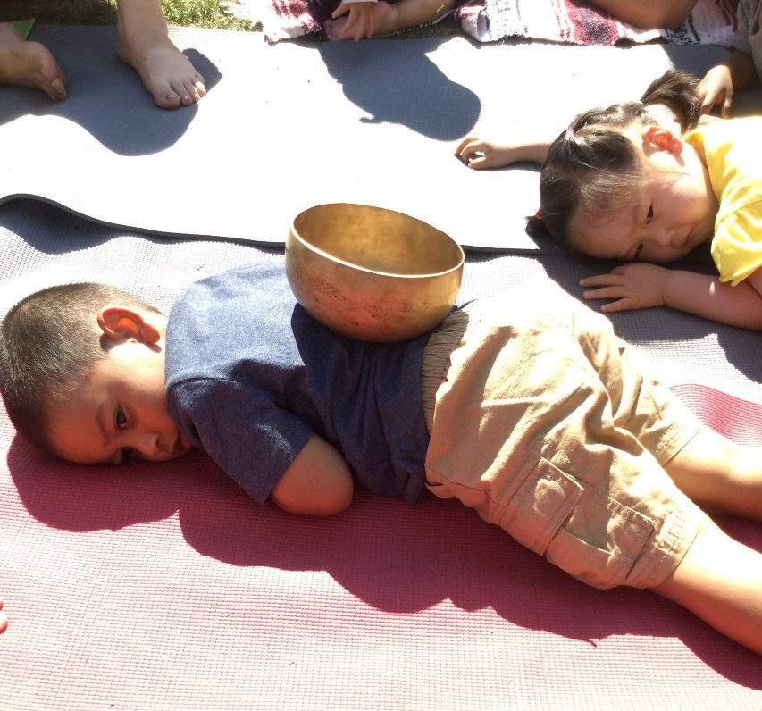
The ECE Lab School recognizes that each child is unique and has a variety of ways to express themselves. Educators commit to supporting children in communicating and expressing themselves in positive ways.
We assist, support and scaffold children’s developing self-regulation skills while promoting problem solving and offering assistance with solutions that are respectful of all. When children are calmly focused and alert, they are best able to regulate their emotions. Children may pay attention, ignore distractions and begin to understand what others are thinking and feeling.
Dr. Stuart Shanker states, “the better we understand self-regulation, the better we can implement educational strategies that enhance students’ capacity to learn and develop the skills necessary to deal with life’s challenges.”
Educators at the ECE Lab School support children’s emerging self-regulation by modelling and scaffolding self-awareness and calming skills. We use strategies such as yoga, breathing techniques, and a calming supportive voice for a child to engage in holistic mindfulness. We strive to create an environment which reduces stressors as well as providing a predictable, yet flexible routine which encourages the children to feel the rhythm of the day. Visual schedules support the children in anticipating what comes next in the day. A predictable, yet flexible routine is responsive to the children’s changing needs and allows for modifications. This fosters self-awareness and empowerment.
An aesthetically pleasing environment created with the children assists them in self-regulating in a calm atmosphere, conducive to self-constructed learning. A variety of multicultural music and sensorial materials such as water, clay, sand and dim lighting provides a peaceful ambiance.
The emotional environment of the classroom is one of respect where children are listened to and have a safe outlet to express themselves. It is a space where children express their thoughts and educators acknowledge and validate their feelings. Through verbalizing children’s emotions (i.e. “You’re crying. It looks like you are feeling sad.”), educators validate the child’s feelings while providing them with the language to express themselves in a way others may better understand.
Educators are intentional about designing and building curriculum where children have opportunities to exercise problem solving skills, persevere and overcome challenges. This prepares each child for transformative success within the school environment and beyond. Early educational reformer John Dewey said it best: "Failure is instructive. The person who really thinks, learns quite as much from his failures as from his successes." Children are provided support to endeavor, persevere, and attain their goals.

Building on the hundred languages of children, the ECE Lab School believes in providing children opportunities to build knowledge in their own ways and also support children in the expression of their hundred. When children are truly listened to, and when this is transparent in practice, they feel a sense of belonging.
Listening helps us respect the voice of the child, guiding the process; suggesting when to step back, move in, add an idea or just share quietly in the presence of the child. Listening brings us to the moment, each moment as a valued and honored exchange. It slows us down and reminds us to take pause and allow the space and time for the child to be the center of their own learning. It is in these moments that we can truly appreciate and celebrate the Hundred Languages of children.

We VALUE… and foster the children’s exploration, play and inquiry;
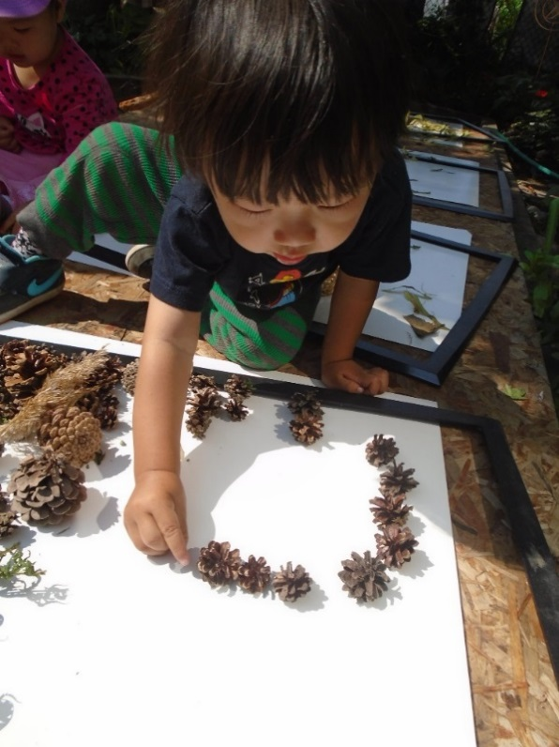
Seneca ECE Lab School has always held a strong belief in the value of play, inquiry and children’s active explorations. We support children in their natural desire to learn through rich, inviting and stimulating environments. We value child initiated emergent curriculum that has inquiry at its core. We strive to be up-to-date with the latest early learning trends and research and explore current theories to support curriculum planning, environmental design and the on-going development of our pedagogy.
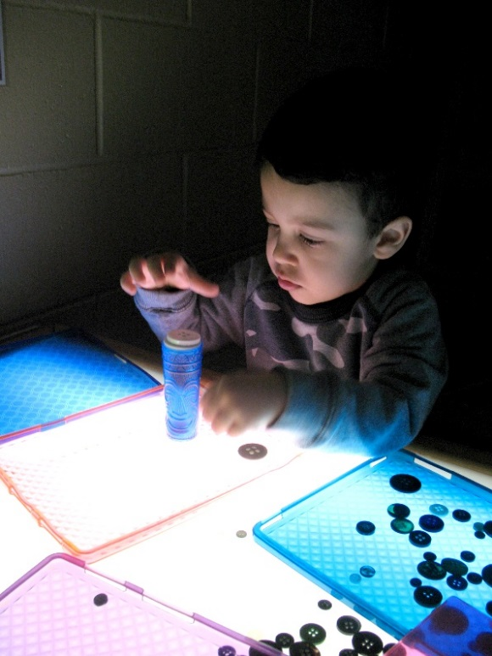
We uphold the values of the constructivist and social constructivist approaches derived from the philosophers Piaget and Vygotsky. In the social-constructivist classroom the focus is shifted from the teacher to the child, where children are active protagonists in their learning. The classroom is not a place where the teacher pours knowledge into students, ‘filling an empty vessel’ but rather a place where children are encouraged to be active in their own processes of learning. Educators view themselves as co-learners; supporting and facilitating children’s investigations.
The process of going through the trials of discovery alongside the children allows for a deeper connection to form between the children and the materials, the educator and the children and the children and each other. It supports the creation of a true community, a deeper connection to one another.
Rich, natural, open ‘loose parts’ are embedded throughout the curriculum so children can discover opportunities to investigate, test, hypothesize and generate ideas for the next steps of learning. These are valuable extensions to the already rich and diverse materials in the classrooms. These can also be encountered in our natural outdoor environments/gardens, our multiple learning laboratories such as, the messing about with science lab, water and sensory lab, sound atelier and light and shadow lab. Inspired by the philosophy of Frances and David Hawkins, the play labs including ‘messing about’ areas are modified to meet current interests and pursuits of the children. Children, together with adults, look at learning through a lens of wonder. Multiple possibilities and perspectives are examined during this process.
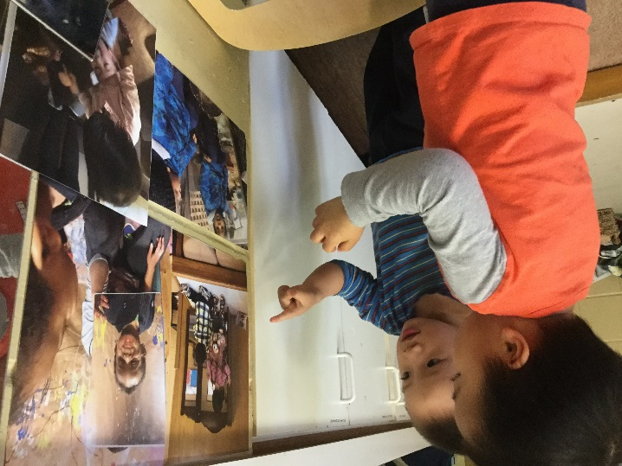
Documentation is an essential part of the curriculum and a valid component of communication. It provides children the opportunity to re-visit and re-call their learning experiences and enables them to deepen their understanding and make further connections.

Re-visiting experiences, strengthens children's interest and sparks further investigations. We view pedagogical documentation as an important research tool for children to share, collaborate and extend their thinking and theories to enrich further learning. A true testament of how learning happens.

We Value… planning and creating positive learning environments and experiences in which each child’s learning and development will be supported;
We strive to create an environment that is aesthetically pleasing, providing beautiful and authentic materials for the children to encounter. The care and purposefulness we place on creating an authentic and beautiful space in the classroom silently conveys the message that this is an important and meaningful place to people who encounter it. The environment is more than just beautiful aesthetics it is an expression of philosophical choices.
We view the environment as rich and full of potential with clear choices as a reflection of our values and views. This is relevant in both our indoor and outdoor learning environments; one not more important than the other. Both of these environments are designed to provide stimulating, engaging child initiated choices.
All areas of the classroom are open and accessible; with carefully selected materials to build upon and enrich observed interests. Educators have designed and organized classrooms providing equal value to the view of these spaces as the ‘third teacher’. The environment is carefully formed, giving thought and critical reflection to all materials, as well as the possibilities for the children to extend their thinking and develop new theories. What appears to be nothing more than a stick comes alive when the children encounter it from a place of creative thinking and inquiry. It can become anything from a cell phone, to part of a structure, a paint brush to something used to create music. Open-ended materials allow the children to define their use in the moment.
We chose the materials based on our observations and listening to the children so that the children can create their own opportunities to engage in literacy, math, science, group and individual experiences. Open-ended loose parts and intelligent materials enable the children’s ability to construct knowledge. Invitations and provocations enrich the environment and provoke children and adults to “mess about”. The ECE Lab School is committed to setting an example in the use of natural, recycled, re-used and sustainable materials.
We are committed to supporting children in building a relationship with the natural world. Educators at the ECE Lab School are passionate about nature and connecting children to its natural wonders and provocations in hopes to provoke a lasting connection, empathy and care for all of its richness. Our classrooms, curriculum and environments provide daily encounters with nature and natural phenomenon, which embraces a nature pedagogy at its core.
Educators assist, support, and are co-learners with children in making discoveries and in supporting future explorations. We honor each child’s process of learning and the many languages that children come to know, understand, construct and express.

We VALUE…and provide child-initiated and adult-supported experiences;
Children are the focus and drive our curriculum. We observe, follow and embrace the child’s lead. Our image of the child continues to evolve as we see children surpassing our image of them and see their competency unfold daily.
Children not only initiate and choose their experiences, they involve themselves in the planning and fully engage together with educators in the next steps of curriculum. Through this, they establish their own community of building and creating together. A true representation of collaborative and shared learning. Children not only guide the program they are the program.
Recognizing, honoring and respecting children’s ways of expression is demonstrated in the care we take in selecting materials for our rich environments. In this, children are active in building, constructing and expressing learning in multiple ways; to be heard through music, art, dance, writing, problem solving and so on. Educators recognize, value and respect each child’s individual learning style and outlets for expression.

“Children are miracles.
Believing that every child is a miracle can transform the
way we design for children’s care.
When we invite a miracle into our lives we prepare
ourselves and the environment around us.
We may set out flowers or special offerings.
We may cleanse ourselves, the space, or our thoughts of
everything but the love inside us.
We make it our job to create, with reverence and gratitude,
a space that is worthy of a miracle!
Action follows thought.
We can choose to change.
We can choose to design spaces for miracles,
not minimums.”
-Anita Rui Olds, 1999

We VALUE…and incorporate indoor and outdoor play, as well as active play, rest and quiet time into the day and give consideration to the individual needs of the children;
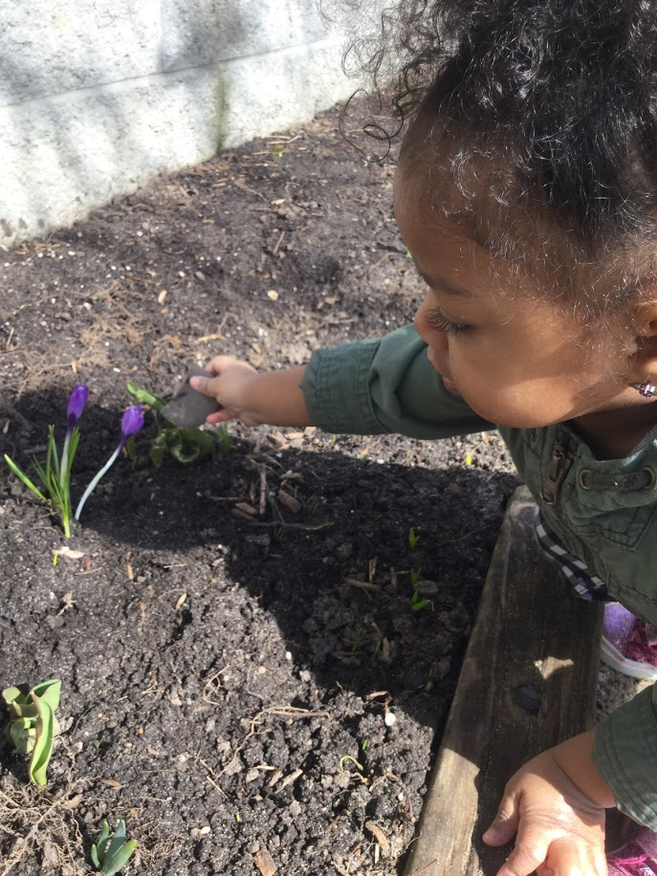
Our outdoor environments are thought of as outdoor classrooms; just as important and full of potential as all of our indoor spaces.
“To nurture ecological identity in young children, we invite them into relationship with the world beyond walls and with the creatures that live there. We invite them into ethical thinking anchored by the compassion that comes from caring and engaged relationships. We invite them to come home to the Earth, and to live honourably in that home.” – Ann Pelo

Children set the tone and lead us through the rhythms of our day; through periods of active play, quiet engagement, individual investigations, time to come together as a group and time to simply rest. By entrusting the children to lead us through the day, we embrace a sense of vulnerability, and learn the value of being comfortable with uncertainty and the beauty and wonder it can allow for.

Every moment of each day is valued equally; from the moments of inquiry to time spent changing a diaper, from time spent in nature to the time it takes to put on your shoes. The moments spent caring for individual, physical needs are viewed as an opportunity to empower the children to be independent, to gain self-confidence and to be supported through the process as much or as little as they need. This image of the child helps educators form authentic relationships with the children and support them in reaching their full potential as capable, confident citizens with rights.

We VALUE…and support staff who interact with the children at the ECE Lab School in relation to continuous professional learning;
Seneca College ECE Lab School supports, values and appreciates the continuous learning of its educators. They are committed to ongoing collaborative and individual professional learning. The ECE Lab School encourages educators to seek and value the process of lifelong learning and to be committed to on-going self-reflective practice.
Educators are provided with opportunities to attend workshops, conferences and to update and train on curriculum and policy changes, as this yields personal growth, greater job satisfaction, and higher quality programming. Professional development opportunities are afforded based on personal interest and the ongoing needs of the ECE Lab School. Educators are seen as professional leaders in the field, and share their vast knowledge in hosting and presenting various workshops and conferences as well as in-house tours.

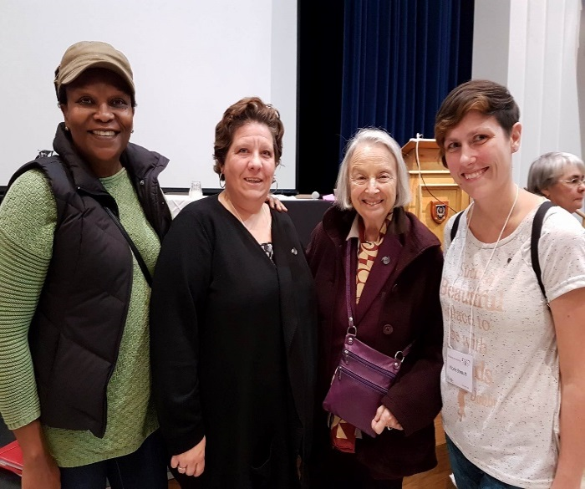
Educators are encouraged to review and reflect upon the how, why, and what we do with young children on a continuous basis; addressing the gaps between theory, pedagogical practices and inherent beliefs. The intention is to critique, analyze and reflect on individual practices as well as collaborate with peers. By placing value on collaborative learning and incorporating the expertise, experiences and perspectives of others, the employees of the ECE Lab School foster a supportive environment for communal as well as individual growth and development. Employee meetings as well as scheduled program time allow for large and small group discussions and collaborations. In addition, employees are observed regularly and receive a formal annual evaluation of their delivery strengths and opportunities for growth in which new goals are set, collaboratively.

The ECE Lab School is established as a leader in the field and has demonstrated an on-going commitment to extending professional development opportunities to the larger early childhood education community. We have inspired and propelled others to move forward in supporting the emergence of the evolution of their own pedagogical thinking and practices. The ECE Lab School has been established as a community consultant in helping to strengthen the philosophical values at various early learning centers as they seek to explore change and move towards a play based, emergent curriculum and holistic model.

The ECE Lab School values its relationships with other educators both locally and internationally. We are committed to establishing communities of practice to further promote growth, learning and a sense of community both locally and online. Our commitment to professional learning and growth is further demonstrated in various vast and varied social media connections. On-line communities such as: Pinterest, Instagram, Twitter and Facebook act to support and engage with the larger international community and serve as a means for connecting, inspiring and sharing in learning.

“…pedagogical leaders create a sturdy infrastructure that supports the teaching and learning process. Working together with their learning communities, pedagogical leaders define the vision and values that are central to their program. They challenge and empower educators to see themselves as researchers where they become interpreters rather than mere implementers of a curriculum framework. Pedagogical leaders commit to using practices and allocating resources that build an intentional culture where learning and growing happens in relationship with others. Just as the province continues to invest in their long term vision for children and families, so must we commit to pedagogical leadership” (Think, Feel, Act 2013)

The educators in the ECE Lab School mentor ECE students completing their field placement practicums. In this role, we translate and share our philosophy, values and beliefs to engage and pose more critical thinking in the students. We help to build their understanding of theory and how this translates to practice. We strive to make students feel welcome and part of the team, developing a personal connection, while challenging them to explore other perspectives. Educators include students in pedagogical documentation in order to inspire a love for teaching and learning and appreciate the values of being a part of an early learning team.
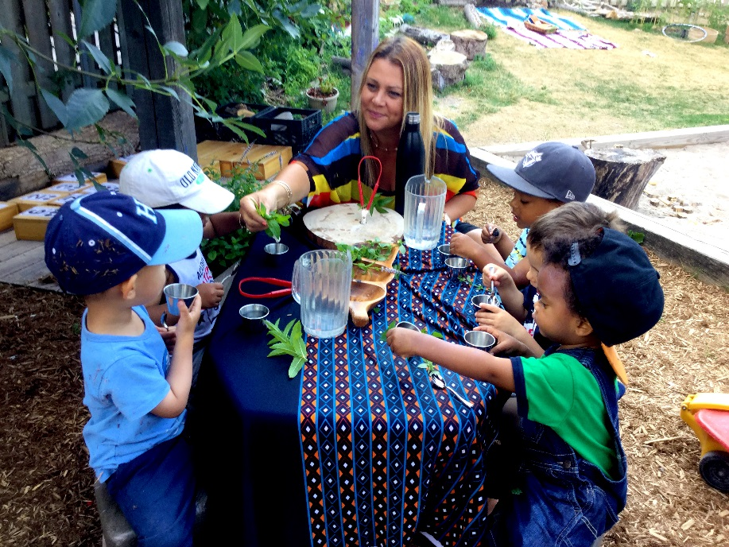
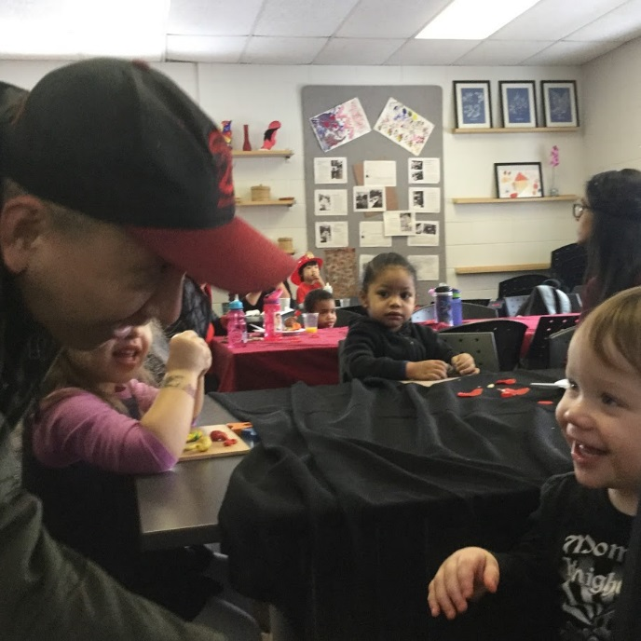
Looking down from the banks of the river, we are in tune to our voice. Our reflection honors the voices of all: the children, the families and the educators. We are beginning to understand and interpret the underlying philosophy of Reggio Emilia. Relationships between and among children, families, educators, students, materials, and the environment are all interconnected. Thus, emerges a support network centralizing on the child. Our team has grown, now comprising not only of the educators of the Lab School, but central to the child, families, and community. As we grow, we learn together.

We push off once again from the river bank. Paddling, we synchronize our oars, encouraging each other to keep tempo, celebrating our accomplishments while supporting each other’s strengths through challenging rapids. Respect is given to the changing river landscape. We embrace the uncertainty, knowing that it is part of the journey. With hopeful hearts we share our dream to continue on Ontario’s journey of a new pedagogy.

We hope to mentor and inspire future and current educators, and to contribute to the wider community. We hope our passion, dedication, and commitment will inspire a new generation of educators. We listen to the river – a new adventure is taking hold, the hidden current is flowing rapidly, and new water is surging. Where it will take us, only the river knows.

-Leading the way: Recognizing the Role of Early Learning Lab Schools in Canadian Universities and Colleges (Lab School Educators, 2012).

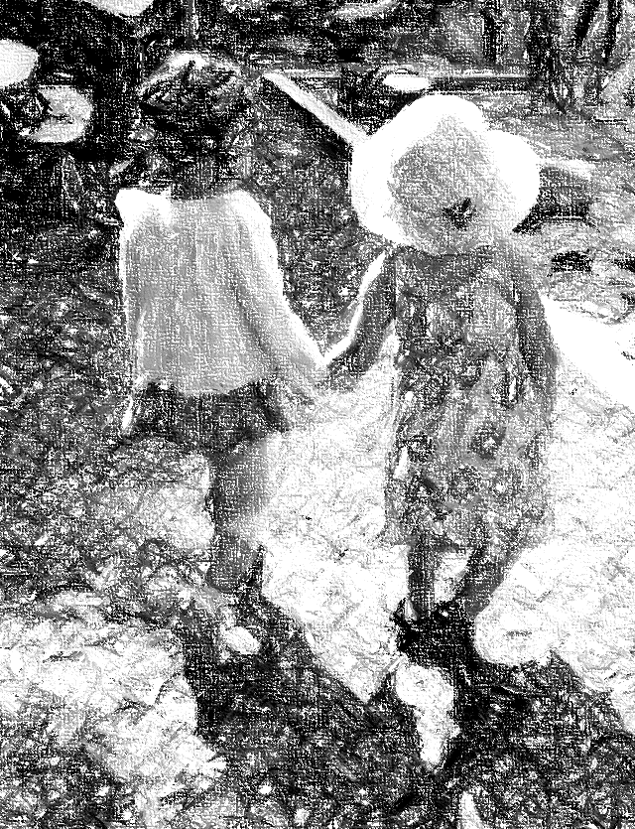
As educators, we continually explore our held views to transform our practice; a constant evolution. Continuing to create and sustain the conditions for learning and an environment is a journey into the unknown. What we’ve learned thus far, educators must listen, engage, be present, interpret and attempt to decode and understand each child’s language. Relationships are one of the foundations for learning; a relationship has to exist. If there is love and an authentic relationship, learning will follow.
Each child is viewed as an individual with unique gifts, talents and expressions of their inner self.
The act of listening speaks to the values we want to share with children. The belief that they are respected, valued, honored and celebrated for the Hundred. That we, as educators, trust in their capabilities, the environment, ourselves and the process of learning.
Listening is not a passive act but a strong expression of the values and beliefs we hold as educators. It requires one to be immersed. Immersed in the moment, truly listening, hearing and feeling. Intensifying ones emotions, elating in the process. Getting lost in the child’s thoughts, the child’s process. It creates an experience that is truly magical!
We must be able to take the risk – the risk of the unknown – the risk of success and the risk of failure – of not understanding or interpreting the child’s thoughts, feelings, actions and pedagogy.

We are listening with our ears, our eyes and our hearts.

Policies and Procedures
Our policies and procedures are critical to ensuring the values reflected in our philosophy are transparent, communicated and implemented by all members of our community. Through the lens of the following policies and procedures, we hope to give members of our community insight into how we ensure the values and principles embedded at the core of who we are and who we want to become at the ECE Lab School are put into practice. We welcome you on this journey of learning as an equal contributor and true member of our community.

Wait List Policy
Seneca College ECE Lab School’s waiting list policy is flexible in order to ensure it allocates spaces as they become available.
Being on the wait list does not guarantee that a space will be offered in the timeline that has been requested; therefore, we recommend that families complete wait list forms with at least three other child care centres of their preferred choice.
Seneca College ECE Lab School gives priority to different groups which effectively moves them up the waiting list. The different tiers of our waiting list are:
- Families with a child already enrolled in our program
- Students and Employees of Seneca College
- Emergency transfer by Children’s Services
- Other families
There is no fees associated with placing your child’s name on our wait list.

Wait List Form
Families looking for a childcare space in our program, must fill out our wait list form by going on-line at http://www.senecacollege.ca/community/childcare/newnham/general-information/waitlist.html. These forms are sent to the Lab School manager who will place the names on the waitlist in order of receipt. In addition, families who will be requesting subsidized child care fees, will need to contact Toronto Children’s Services at https://www.toronto.ca/community-people/employment-social-support/child-family-support/child-care-support/ and complete an application. Toronto Children’s Services will then place the family on our waitlist in their system. The Lab School Manager will access and cross-reference the Toronto Children’s Services wait list with our own on a monthly basis. Any families who appear on the Toronto Children’s Services wait list and are not already on the Lab School wait list will be added based on the date provided.
Families are required to specify their child’s name, date-of-birth and their desired date of admission. Based on the requested date of admission, and availability of space, we will determine an appropriate time for us to contact families to come and tour the facilities with their child and receive a registration package.

Request for Information
The Ministry of Education mandates that families can request to have access to view our wait list. The ECE Lab School does not maintain a separate, anonymous wait list. Therefore, to maintain confidentiality, when a request is made for a physical copy of the wait list, the ECE Lab School will provide one within fifteen (15) business days for the month and age group of the start date requested by the inquiring family. The names of other families on the wait list will be redacted.

Offer of Space
As a space becomes available, we will offer it to the first child on the wait list. Notice of vacancy may be anywhere from 2 – 12 weeks prior to enrollment depending when notice of a withdrawal is received. Families are required to accept or reject the offer within two (2) business days. Families who do not wish to accept the space for the date offered reserve the right to keep their child’s name on the wait list for a future opening if and when one becomes available.
All families on the wait list are contacted during the month of June to confirm their interest for enrollment in September.
Upon acceptance, the registration fee and deposit is required. The deposit will be applied against the last month’s fees when the child leaves the Lab School, if proper notice is given. Families are required to give two weeks’ notice of withdrawal from Seneca College ECE Lab School, in order to contact and prepare incoming families.

Registration Fee
A onetime non-refundable fee of $50 is due for each child and must be submitted with the completed registration information package.

Deposit
The deposit fees paid upon admission are applied to the families last month’s fees when the child is withdrawn from the ECE Lab School provided that the family has given two weeks’ notice prior to withdrawal. Failure to notify the Lab School Manager in writing two weeks prior to withdrawing your child/children from the program will result in the loss of the deposit and an invoice for the full fees applicable for the child’s last month. The deposit paid by the family will be deducted from the last month’s fee in all other cases.
Full deposits are as follows:
Toddler’s: $360
Preschooler’s: $250

Families requesting subsidized spaces are urged to contact Children’s Services for an appointment to confirm their eligibility. For families whose fees are subsidized the deposit is two week’s fees, based on the daily rate specified by Toronto Children’s Services. In addition, when families requesting subsidy are contacted about an available space, they are encouraged to contact their case worker to notify them of the available space and hopefully expedite the subsidy process. Following this, the Lab School Manager can confirm the space availability with the case worker.
Every effort will be made to provide as much notice as possible when a space becomes available. Perspective families should keep track of their child’s status on our wait list and are encouraged to contact the Lab School manager 2-4 weeks before the requested admission date to see if a space will be becoming opening.

Admission
We welcome you and your family to the Lab School community. The Lab School admits children from the ages of eighteen months to four years. We value our view of the child, the family and the educator (see Program Statement) and value every person as a contributor and creator of our community. Each person comes with their own unique story, and we respect each person as an individual. We look forward to being a part of this next chapter.
As stated in part in The Preamble of the Ontario Human Rights Code:
“It is public policy in Ontario to recognize the dignity and worth of every person and to provide for equal rights and opportunities without discrimination that is contrary to law, and having as its aim the creation of a climate of understanding and mutual respect for the dignity and worth of each person so that each person feels a part of the community and able to contribute fully to the development and well-being of the community and the Province…”
Educators share with children a wide range of cultural traditions, customs and languages in an authentic, everyday and meaningful ways. It is our goal to include the teachings of Indigenous Canadian cultures into our curriculum. Families, students, educators and community members are a valuable resource and are encouraged to share with us and the children their knowledge, traditions, language and customs.
The Lab School is a safe space for people of all backgrounds, identities, orientation and family structures. We value each person for who they are and the incredible gifts each person has to offer our community.
Upon accepting a childcare space for your child/children, families will be asked to visit the Lab School with their child for a short tour and to pick up our registration package and family orientation handbook. During the tour, the Lab School Manager will highlight the salient points of the admission process such as associated fees and payment processes, access card registration and information about the various components of our program specific to being a teaching lab school such as the iLook system and our connections with the ECE program at Seneca College. During this initial meeting, the Lab School manager will also go over our orientation procedures and other procedures relevant to the transition into our community as well as our withdrawal policy.
The following forms must be completed on or before your child’s first day at the Lab School:
- Registration Package, including health/medical information, emergency and release information
- If the child has any allergies, the full emergency plan, allergy/ restriction forms and forms to be signed by a physician MUST be completely filled out before the child can be left in our care without their families present. These can be found in the Registration Package.
- Security Access Card Form (to enter ECE Lab School building)

Parking
There is a limited drop off/pick up parking lot allocated for the childcare centre. These spots are to be used for drop off and pick up purposes only, so generally a 20 minute time limit is imposed. The parking spots are located at the entrance to the lane leading to our building. The parking spaces closest to the Lab School building are designated as accessible parking spaces only. If you do not have an accessibility tag for your car, you will be ticketed for parking there. Please note that these parking spaces are monitored daily and tickets can and will be issued for misuse. Please ensure that you have given a current license plate number to the Lab School Manager for your vehicles so we can inform security of who may be using the drop off and pick up spots. If you need to park for a longer period of time, you will need to park in one of the campus parking lots and pay the standard parking fees.
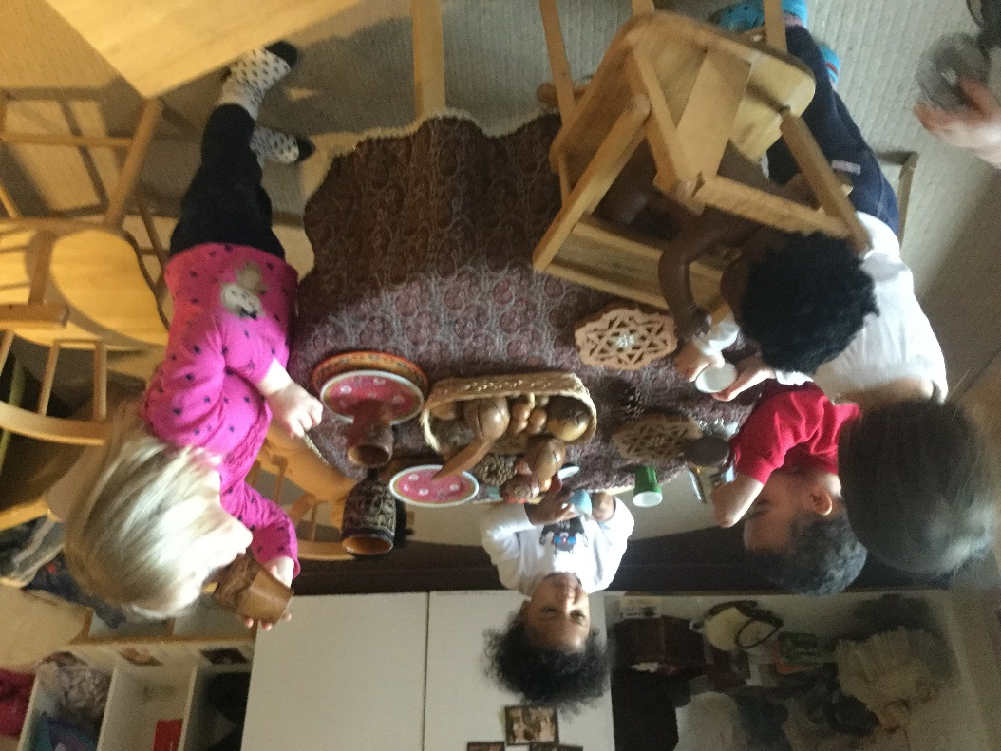
The Ministry of Education and Toronto Public Health Department require all children who attend group care settings to have up-to-date immunization. A copy of your child’s immunization record must be provided. If you choose not to immunize your child (for any reason) a completed and notarized exemption document must be provided to be kept in the child’s file. To minimize the risk of spreading diseases, children and employees who are not immunized may be excluded from the program at the ECE Lab School during times of an outbreak.
Seneca Lab School accepts children with special needs as long as we can provide a safe, supportive environment for the child and the other children in the program. When a family member of a child identifies that the child has one or more special needs, the Lab School Manager, the Resource Educator (please read our inclusion policy) and the family meet to review the child’s accommodations. Before this meeting takes pace, families will be required to sign a release of information form so that we can provide the relevant information to the Resource Educator consultant and any other relevant third parties.

Inclusion Policy
The purpose of this policy is to ensure all employees and families are aware of and adhere to the expectations for the inclusion of children with extra support needs.
Seneca Lab School is committed to an inclusive child care system that promotes positive and healthy environments for all children. Seneca Lab School's Mission Statement outlines the commitment to equitable access to high quality child care for all children.
Children have the right to be cared for in environments within their own community where their needs can be met and they can develop to their fullest potential. Seneca Lab School also supports the six elements of inclusion which have been defined by Special Link, the National Centre for Child Care Inclusion. These are as follows:

Zero Reject – no child is excluded on the basis of accessibility needs.
Natural Proportion – programs include children with disabilities in approximate proportion to their presence in the population.
Full Participation – activities and routines are modified and adapted to include children of all capabilities.
Same Range of Program Options – Families of children with disabilities have the same options that families of children without disabilities have.
Maximum Feasible Family Participation – Families are actively encouraged to participate in all aspects of our program and community.
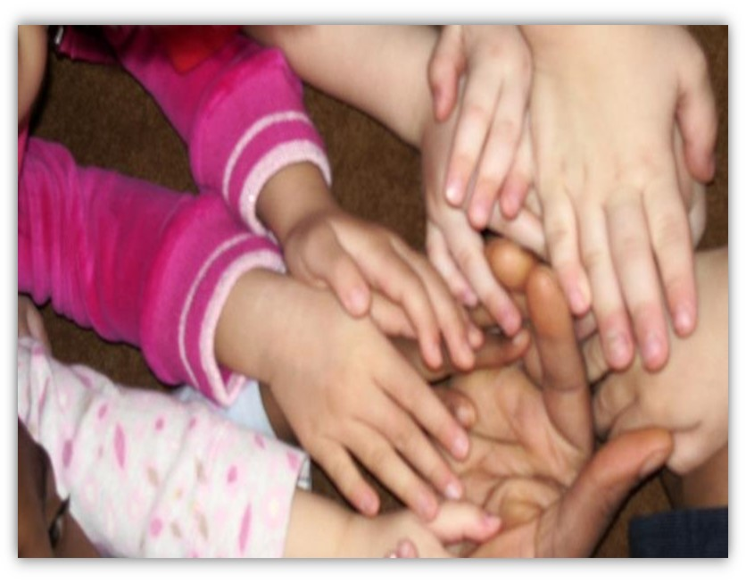
Pro-Action for Community Inclusion – Employees and families promote inclusion in the whole community.

Prohibited Practices
The Seneca ECE Lab School and any member of the Lab School community members and families shall not permit:
- Corporal punishment of the child
- Physical restraint of the child, such as confining the child to a high chair, car seat, stroller or other device for the purposes of discipline or in lieu of supervision, unless the physical restraint is for the purpose of preventing a child from hurting himself, herself or someone else, and is used only as a last resort and only until the risk of injury is no longer imminent
- Locking the exits of the Lab School premises for the purpose of confining the child, or confining the child in an area or room without adult supervision, unless such confinement occurs during an emergency and is required as part of the licensee’s emergency management policies and procedures
- Use of harsh or degrading measures or threats or use of derogatory language directed at or used in the presence of a child that would humiliate, shame or frighten the child or undermine his or her self-respect, dignity or self-worth
- Depriving the child of basic needs including food, drink, shelter, sleep, toilet use, clothing or bedding; or
- Inflicting any bodily harm on children including making children eat or drink against their will.
Note: Any one committing the above prohibited practices will be removed from the Lab School. This may result in immediate withdrawal of their child from our program, or immediate termination of employment. Any and all appropriate child protection and other agencies will be notified.

Financial policy
Fees are due as indicated on your invoice, which you will receive at the beginning of each month.
Fees are paid regardless of your child’s illness, absence, vacation or statutory holidays.

Child Care Fees
Toddler’s: $72 per day
Preschooler’s: $50 per day
Late Payment Fee
Fees paid after the due date are subject to a late fee charge of $15.00 for each month up to two (2) months after which time the Lab School will issue a notice of withdrawal to the family and will require full payment.
Payment Information
The Seneca ECE Lab School accepts payment in the form of Debit, Visa or Mastercard. To submit a payment, families must bring their invoice and card of choice to the Lab School for the Lab School Manager or designate to process with the machine.
It is recommended that families keep their copy of the debit/credit card receipt for future reference. Any receipt for a payment that may be refunded in future (ie. Access card deposit) will be needed in order to process the refund.
Income Tax/Donation Receipts
Receipts for child care fees are issued on or before February 28th each year. These receipts may be used when filing your income tax. The debit/credit card receipt from payment will act as your monthly receipt and proof of payment.
Donations are welcome and will be used to enhance the quality of the program for the children. Tax receipts are issued for monetary donations and for donations of large pieces of equipment.

Hours and Days of Operation
The ECE Lab School is open year round Monday to Friday from 7:30 a.m. until 6:00 p.m. The Lab School closes for the following statutory holidays:
Family Day (February)
Good Friday (March or April)
Victoria Day (May)
Canada Day (July)
Civic Holiday (August)
Labour Day (September)
Thanksgiving (October)
December 24 – January, dates to be determined (Return date varies by year based on College closures)

Unforeseen Closures
The College will notify employees and families via radio and/or TV broadcast of campus closures before 7:30 a.m. CHUM FM, CFRB AM, CFTO TV, CP24, CBLT TV, and local radio stations will broadcast news of college closures. In addition, the College changes the switchboard message indicating that the College is closed. If the College is closed, the ECE Lab School closes as well. If there is bad weather early in the morning, please listen to one of the above stations.
If the ECE Lab School must close during operating hours, because of snow or a storm, we will notify you by telephone so that families can arrange for their child to be picked up as soon as possible.
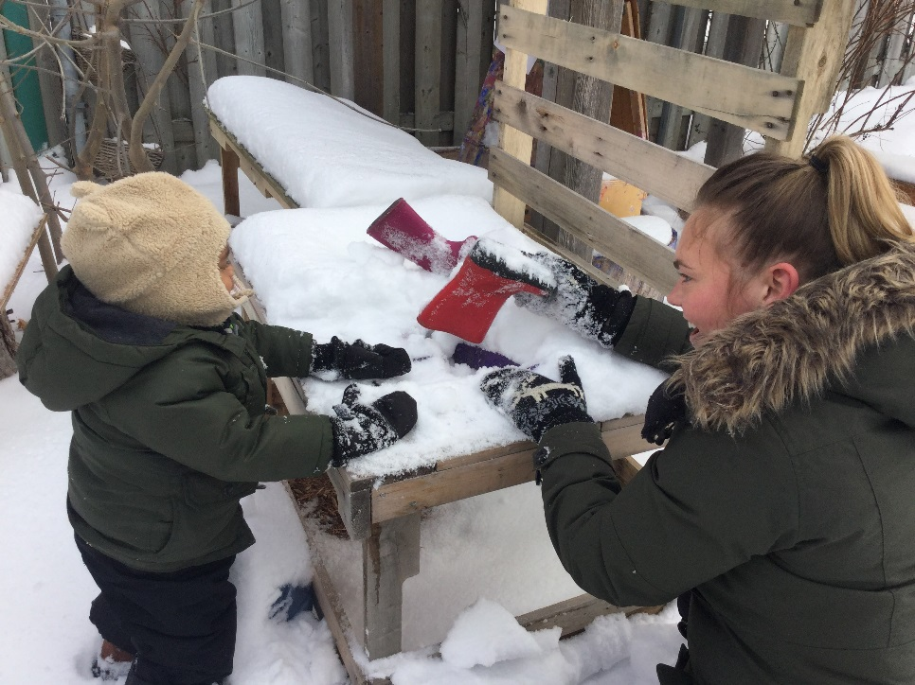
If weather conditions prevent you, or a designated alternate, from reaching the ECE Lab School to pick up your child before closing, a minimum of two employees will stay and care for the child until you or a designate arrives. We will maintain proper child: educator ratios while any children remain at the Lab School.
It is inevitable that power failures will occur from time-to-time. The emergency lighting for the hallways is automatic. It comes on for about one hour whenever the power is off. Educators will comfort the children, explain the situation and model for them how to remain calm. If the power is not restored within two-hours of a power failure, the ECE Lab School may contact you to pick up your child.
Unless an emergency situation requiring evacuation accompanies the power failure, the ECE Lab School will remain open. If weather conditions do not permit us to maintain the building at a safe temperature, we will notify families by telephone of the need to pick up their children, and move to a safe site until all the children are picked up.

Employees/Educators
Early Childhood Educators (Full-time & Part-time) at the ECE Lab School are Registered Early Childhood Educators (RECE) licensed by the College of Early Childhood Educators. We employ and mentor Child Development Practitioners (Apprenticeship) and 4th semester ECE students working towards qualifications to work alongside RECE’s.

Child: Educator Ratios
Child: Educator ratios at the Lab School comply with the requirements of the Child Care and Early Years Act, 2014. Our goal is to maintain the following ratios and maximum group sizes:
Age | Child: Educator Ratio | Group Size
18 - 30 months | 5:1 | 10
2½ - 4 years | 8:1 | 16

Ratios are maintained at all times except during arrival, departure and rest periods in accordance with the Child Care and Early Years Act 2014 (CCEYA) -- when they may be reduced to two-thirds of the requirement. The length of arrival and departure times varies from room-to-room and from time-to-time. We schedule shifts to reflect the realistic length of time when there is a fluctuation in numbers of children.

Orientation/Transition
To acquaint new families with the ECE Lab School and educators, a family member is required to visit with their child prior to enrollment. During these visits, families and children will tour the building and meet the educators.
As we begin our journey together, families are asked to join their child in our program during the first week for an opportunity for everyone to get to know each other and begin building an authentic relationship. The length of this transition period will be determined by the family, Lab School Manager and the educators, taking into consideration the age of the child, their previous experiences and what best fits the needs of the family. A typical transition week will be:
Day 1: Families will visit with their child from around 9am until 11am, engaging in encounters with learning, getting a more in-depth tour of the classroom environment and getting to know the educators and other children.
Day 2: Families will visit with their child from around 9am and stay to enjoy lunch.
Day 3*: Families will visit with their child, enjoy lunch and transition into sleep/rest time so the child can get accustom to the rhythm of the day with the help of their family member. If the child is unable to fall asleep, families will take their child home and try sleeping again the next day.
Day 4*: Families will visit with their child, enjoy lunch and transition into sleep/rest time. If the child sleeps, families will go home when they wake up.
Day 5: Families will drop off their child in the morning. As this is usually the child’s first full day, families are requested to pick-up closer to 3pm if possible.

*Family members may leave the room for short periods of time to allow their child to get comfortable in the space independently
Following this transition period, based on the needs of the child, families should be aware that they may be called or requested to pick up their child earlier if the children are showing signs of distress while they continue to adjust to their new environment and build a sense of belonging in our community.

Things Your Child May Need
Toys from Home
A stuffed toy, a doll, truck or a small blanket can all be a security object to a child. They are a little piece of home and have a great deal of significance to young children. As such, they are welcome at the Lab School. These objects provide a sense of security when children move from the familiarity of home to the unfamiliar surroundings of the Lab School. As with any toy, there is always the possibility that these objects may get damaged or lost during the course of the day. Though we do our best to prevent this, the Lab School and its employees are not liable for the loss or damage incurred if it does.
Clothing
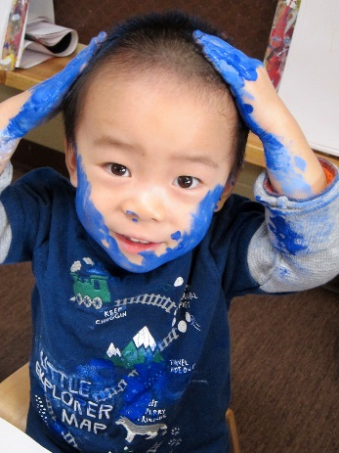
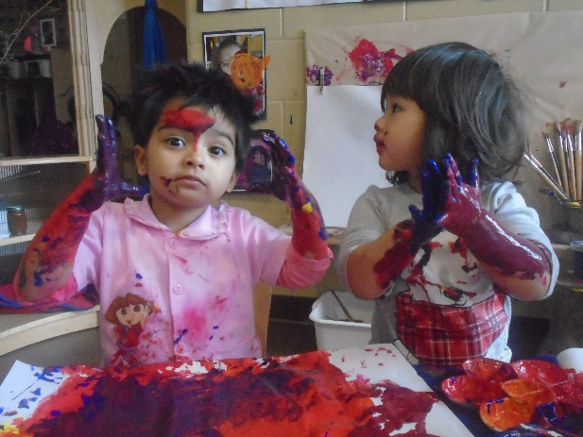
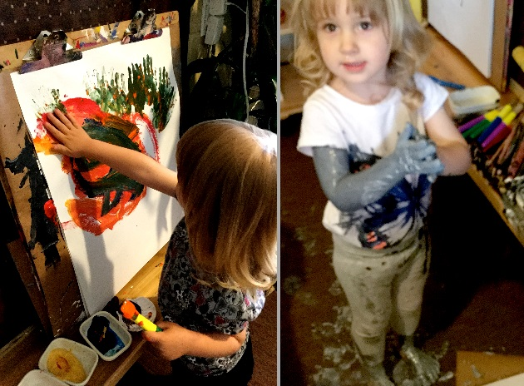
Your child will need at least two complete sets of extra clothing (shirt, sweater, pants, underwear, socks, etc.) available daily. Meal times, water play, accidents and messy play are just some of the factors that make this a necessity. We suggest you dress your child in comfortable play clothing that washes well. This will allow them to explore and create without fear of getting ‘dirty’. Legislation requires us to provide at least two hours of outdoor play (weather permitting) for children. At the Lab School, we view our outdoor environments as equally valuable classrooms for the children to explore. Every type of weather provides a unique learning opportunity for children and a new depth to their relationship with nature. Unless it is below -10 degrees Celsius, there is a thunderstorm or there is a heat/smog alert, expect that your child will be engaging in two hours of outdoor exploration. Providing your child with seasonally appropriate clothing will ensure they are prepared for all elements and opportunities for learning. Please remember that the early days of Fall and Spring can be very unpredictable.

Water Bottle
All families are required to provide a clean, reusable water bottle for their child. The children will have access to their water throughout the entire day. Water bottles must be labelled with the child’s name. Educators may add their own labels including the child’s photo to help the children identify each other’s water bottles as well as their own. We request that ONLY water be placed in the bottles for health and sanitary purposes. Each day, the educators will rinse and refill the bottles with fresh water from the tap, as well as whenever needed. Families are responsible for taking their child’s water bottle home to fully clean and disinfect. Families are welcome to take the bottles home whenever they like, however bottles will be sent home along with any blankets, pillows etc at the end of the week for cleaning.
Remember to label all clothing and belongings with your child’s name. For a complete list of items your child may need, refer to your classroom Welcome Package.

Dropping-Off & Picking–Up Your Child

Arrivals
Children become attuned to the rhythm of the day; the time on a clock is of little significance when compared to their expectation of what comes next in their daily routine. When a child is dropped off at roughly the same time every day, they begin to anticipate and plan what their day will look like; such as some time to explore indoors, then outside, lunch and then nap, the same sequence of events every day. We value and respect the children’s need for time to engage deeply with materials and to explore every encounter to its fullest with others.
When dropped off just before lunch, for example, the child may be looking to have that same time to engage before being ready to eat or rest and their natural daily rhythm is disrupted. To maintain that sense of rhythm and planning for the children, we request that they arrive before 10:00 am so they have adequate time to socialize and engage before moving on to the next transition of the day.
If you know that your child will be absent or late, please call to let the classroom educators know before 10:00 am. If your child is not at the ECE Lab School by 10:30 am and we haven’t received a phone call, we will assume they are not coming for the day and may structure educators accordingly. Occasionally, the children will explore our community environment with educators. By letting us know in advance if your child will be arriving late, we can plan when we may go on these excursions so that everyone has the opportunity to participate.
If your child is not able to arrive by 10:30 am, but will still be participating in the afternoon program, we request that they arrive between 2:30 pm to 3:00 pm so this will not affect other children at nap and rest time. Families are asked to call the centre if their child will be joining the afternoon program before 10:30 am so that we can adequately prepare our staff/ratio numbers.
We will not accept children dropped off between 10:30 am - 2:30 pm. Late drop off due to appointments or unusual circumstances are exceptions and should be shared in advance with the educators.
Dropping Off Your Child in the Morning
Upon arrival at Lab School each morning, it is essential that you accompany your child directly into their classroom or playground. Please ensure that the educator is aware that your child has arrived. Taking the time to help your child get outdoor clothing on or off, get involved in an activity (or with an educator) and to talk to the educator about anything that may be affecting your child (i.e. a rough night’s sleep, turmoil at home, signs of illness, etc.) allows your child some time to get settled into the program before you leave. This also allows the educator to do the cursory daily health appraisal the Ministry of Education requires.
Educators do the health appraisal on a casual basis but it is very significant to the health of all the children in the program. We check the children for signs of ill health (elevated temperature; listlessness; discharge from eyes or ears; undiagnosed skin rashes; unusual irritability, fussiness, etc.) that could affect their participation in our program.
Saying Good-bye to Your Child
At the ECE Lab School we encourage the children to participate fully in saying good-bye. Validating their emotions in this moment is an important part of the process. It can be hard to see the person you love most leave, especially if you aren’t sure why or when they will be back. Taking a moment to say good-bye to your child, letting them know where you are going and when you will be back, helps to build a stronger bond of trust between all. Making this a part of your daily ritual, your child comes to expect and understand that when you say you will be back later, you will. They come to know that you mean what you say and that they can trust your word.

Community Excursions
Our location on Seneca’s Newnham Campus allows us many opportunities to plan a variety of on-campus and neighborhood excursions for the children. Trips to the College, the supermarket, the park, or other interesting places make the ECE Lab School experience more valuable for all the children.
Designated People for Pick-Ups
When you enroll your child, we ask you to provide us with a list of people who you authorize to pick-up. Only people on this list will be allowed to pick-up your child. We ask families to notify us in advance if one of their designated alternates will be picking up their child. Unless you have given us prior written authorization for someone to pick-up your child, they will not be allowed to do so.
Any person who the ECE Lab School employee does not recognize must provide photo identification before the child will be signed out. The name on the identification must match someone on the pick-up list provided.
Supervisor/Designates are to ensure the information is provided (in full) upon admission and documented in the Registration Package and Emergency Contact information form. Supervisor/Designate should review the contact information periodically or when there has been a change communicated with a parent/guardian to ensure accuracy.
If employees are aware of any changes to the information they are to inform the parent/guardian to update the information with the Supervisor/Designate and follow up with the Supervisor/Designate that there is a change of information and parent/guardian has been advised to update the information.

Court Orders & Child Custody
Parents with custody arrangements may request that Lab School employees not release a child to the other parent, however, Lab School employees cannot deny a parent access unless there is a court order stating that there is no access to the child. A court order may also specify the days and times that the parent can see the child. Court orders must be followed.
If there is no court order and a parent requests their child NOT be released to the other parent, inform them that you cannot stop the other parent from picking up their child unless you receive a copy of a current court order.
If a parent makes allegations of abuse against the other parent, inform the parent that you have an obligation to report their suspicion to a Children's Aid Society. You must contact Children's Aid and report the accusation. Advise Parent of their right to report to a Children's Aid society.
If a parent informs you of a change in arrangements but the Lab School does not have written confirmation of the change advise the parent that you will be following the steps below:
- Contact the other parent to confirm change and ask parent to provide you with written documentation of change.
- Document time of call and reason for change.
- Ask the parent taking the child to sign the documentation indicating change. The next time the other parent is at the Lab School they will be asked to sign as well.
- Request for an updated Custody agreement to confirm changes.
- If the parent arrives to pick up the child you have to legally release the child if there is nothing on file to say otherwise, you will then contact the parent and if they feel the police need to be contacted they can do so.
If you have custody papers to state a parental custody arrangement and parents wish to make a change to this agreement, they are to notify the centre in writing confirming that this information has been agreed upon. If there is a custody order or restraining order, the Supervisor or Designate is to take a copy of the information and place with admission information, inform all employees and document this on the Alert Notification.
If the non-custodial parent arrives and insists on taking the child/ren on a date when they are not scheduled to do so, the Lab School employee is to inform the parent it is not their scheduled day and the person would have to wait until you can confirm the change in arrangements. If the parent becomes aggressive you are to release the child/ren and contact 911 to advise of situation. You would then follow up by contacting the custodial parent.

Releasing a Child to an Intoxicated Individual
The Lab School employees must ensure the safety of all children. If a family member or designated person arrives to pick-up children while under the influence of alcohol or other substances and the educators feel the child may be in danger, the educators will assess if they feel comfortable expressing their concern to the person in a private and discrete manner. Educators may call upon the Lab School Manager or designate in charge to discuss appropriate alternatives with the families for the safe dismissal of the child. This may include but is not limited to calling a taxi, family member to assist with the transportation or a suitable alternative as agreed upon to ensure overall safety. If the alternatives are refused, the lab school educators /lab school manager must act in the best interest of the child and follow the obligations of educators under the Child and Family Act.
“A person who believes on reasonable grounds that a child is or may be in need of protection shall forthwith report the belief and the information upon which it is based to a society.” (C.F.S.A. s. 68 (2))
The legislation places additional responsibility to report on individuals who perform professional or official duties with respect to children, listing “an operator or employee of a day nursery”, which encompasses Registered Early Childhood Educators. (C.F.S.A. s. 68(4))
In cases where the alternatives are refused and the educator believe the safety of the child or family members may be in question, the educator or Lab School Manager may call the police as well as the appropriate child protection services department.
Educators are encouraged to follow the following steps:
If a one of the lab school educators assess the parent/guardian/designated alternate picking up a child as intoxicated (drugs or alcohol):
- Tell the person you are concerned.
- Confirm their mode of transportation.
- Offer to call a taxi if necessary.
If the person does not agree to a taxi or another driver:
- Call the police. Tell them a person who appears to be intoxicated intends to drive a child home from the child care centre.
- Dial 88 to inform campus security of the situation and seek their support.
- Try to keep the person and child from leaving until the police arrive. If the person gets upset, angry or threatening, release the child into their care.
If the person leaves with the child in a car:
- Call the police again. Give them the child's address, description of the car and the license plate number.
- Phone the appropriate Children's Aid Society to inform them of the incident.
- Inform the Lab School Manager.
- Report the incident as a Serious Occurrence.

Late Pick-Up of Children
The ECE Lab School closes at 6:00 p.m. We acknowledge that from time-to-time emergencies arise and families are unable to be here on time (or to make last minute arrangements for an alternate pick-up).
If you are late picking up your child, the Lab School employee will ask you to sign a form confirming the time your child was picked up, the educator who stayed late with your child, and the late fee owed. There is a late fee of $15.00 per family up to the first five (5) minutes late and an additional charge of $5.00 for every one minute (1) thereafter. Families will see this fee on their next invoice.
In the case that a child is still at the Lab School at 6:30 p.m. and the employees have not been able to reach the child’s primary contacts, we will attempt to reach the designated alternate emergency contacts.
If by 7:00 p.m. there has been no contact with a family of the child, or with any of the designated emergency contacts, the Lab School Manager or designate will follow protocol and contact the Children’s Aid Society (CAS) to notify them and will follow the directions of the assigned agent.

Accidents & Emergencies
All employees of the ECE Lab School are certified in Standard First-Aid and infant and child CPR.
If an accident happens to your child while they are at the ECE Lab School, the following protocol will be adhered to by all employees:
For trivial injuries (e.g. there are no visible signs of injury), educators attend to the child’s needs and reflect on possible changes they may implement to prevent the same situation from happening in the future. Depending on the circumstances, educators may complete an Accident Report Form.
For minor injuries (e.g. there are visible signs of injury or child has to be seen by doctor.), educators will administer first-aid to the child and complete an Accident Report Form.
When you arrive to pick-up your child, you will be provided with the details of the accident and asked to sign the Accident Report Form to acknowledge the information has been shared with you. You are welcome to request a photocopy of this form if you’d like one.
For serious injuries or serious medical emergencies educators will seek emergency assistance and administer first-aid to your child. An ambulance will take the child to the nearest hospital. A familiar educator will accompany your child. The educator or Lab School Manager will immediately contact you and let you know the details of the emergency and to which hospital your child is en route.

Student and Volunteer Supervision Policy
The ECE Lab School is a teaching facility for the ECE students at Newnham Campus. Serving as a primary field placement experience, we model the program, curriculum and guidance methods the ECE students study in the classroom. The educators in the ECE Lab School mentor these students completing their field placement practicums. In this role, we translate and share our philosophy, values and beliefs to engage and pose more critical thinking in the students. We help to build their understanding of theory and how this translates to practice. We strive to make students feel welcome and part of the team, developing a personal connection, while challenging them to explore other perspectives.
To help support the safety and well-being of children at the Lab School unsupervised access (i.e. when the adult is alone with a child) is not permitted for persons who are not employees of the Lab School. Placement students and volunteers are not counted in staffing ratios.
ECE Student Orientation Procedure
The manager of the Lab School will ensure that all students and volunteers receive an orientation prior to their start date to ensure that all required documents are submitted (ie. Vulnerable Sector Screening, Medical), to review and obtain signatures pertaining to all Lab School policies and procedures, and to help students and volunteers understand the operation of the Lab School and the expectations and responsibilities of their placement/volunteer experience.

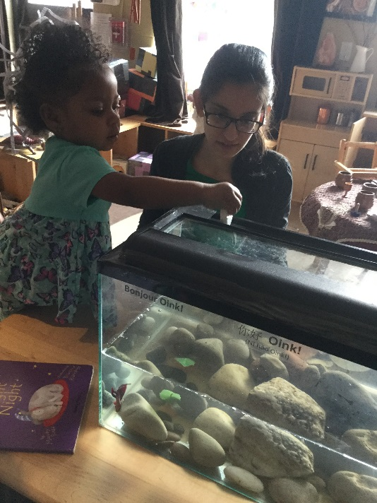
Mentors
All Seneca College ECE Mentors are qualified, Registered Early Childhood Educators (RECE) with the required training and experience to support and mentor students and volunteers.
Duties and Responsibilities of Mentors
- Observe, support and evaluate student/volunteers in their learning experience.
- Assist students/volunteers in gaining awareness of schedule, routines, and program learning opportunities.
- Enforce SLS’s policies and procedures as it relates to the CCEYA 2014 and Seneca College practices.
- Review individual protocol for a child with a medical condition (i.e. anaphylaxis) with each student and volunteer prior to engaging in the Child Care program and annually thereafter.
- Provide a safe environment
- Respect and encourage professionalism and confidentiality
- Demonstrate appropriate, transferrable teaching techniques.
- Serve as positive role models by offering ongoing feedback, encouragement, suggestions, and recommendations through informal evaluations, discussions and meetings.
- Review outlined expectations and goals
- Help students/volunteers to build on their strengths and help them to reflect and improve on their emerging skills
- Offer concrete suggestions to aid students in planning, implementing and evaluating their learning opportunities.
- Review, evaluate and discuss learning opportunity plans, and mid-term and final practicum evaluation.

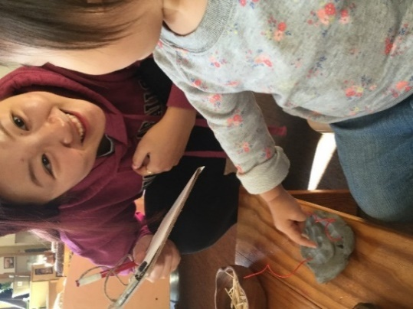
Placement Students
Placement Students deal with many aspects of the ECE profession under supervision of the qualified educators. The degree of involvement varies depending on the length of time the students have been involved in their ECE courses. Near the end of each semester, the second-year students assume greater responsibility for supervising the children and coordinating the program. Essentially, with minimal supervision, the ECE students gradually take over the role of the registered early childhood educator. At no time do we leave students completely alone with the children. Instead, pulling back and supervising in a less visible manner allows them to continue with their responsibility for what happens in the room.

Expectations of Students and Volunteers
- Participate in an orientation with the Lab School Manager and Mentor prior to the start date of placement
- Submit all required documentation to the Lab School Manager prior to the start date of placement.
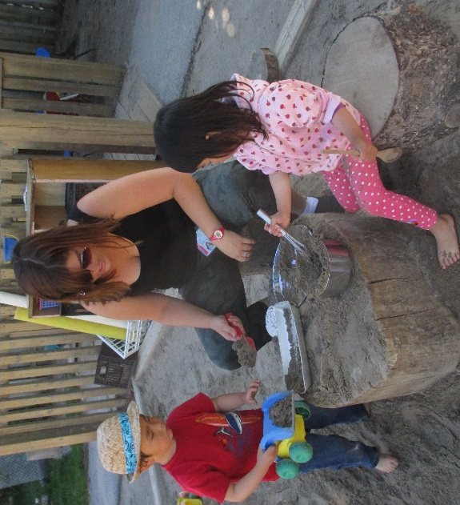
- Read and sign all required policies and procedures.
- Adhere to the Lab School policies and procedures as it pertains to the Child Care Early Years Act, Toronto Public Health, Assessment for Quality Improvement, and Seneca College practices.
- Dress professionally and appropriately.
- Be professional at all times.
- Abide by the terms as specified pertaining to confidentiality.
- Arrive prepared and on time
- Follow through on responsibilities as outlined in the Field Placement Information Manual, Field Placement Evaluations and ECE Course Outlines.
- Ask for advice and/or assistance and clarification when needed.
- Reflect and respond to any feedback provided by field mentors.

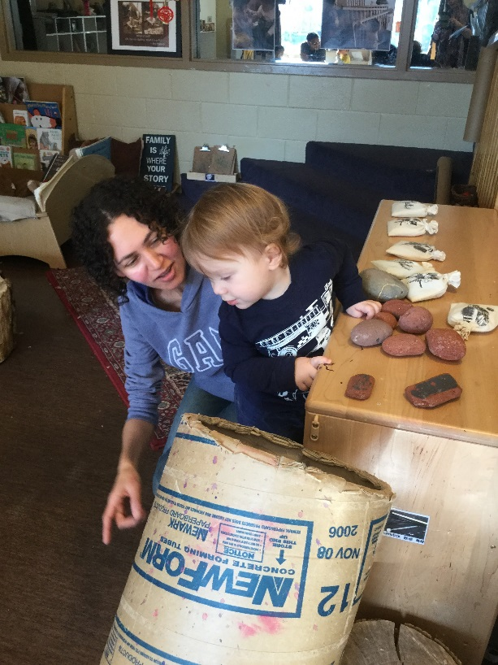
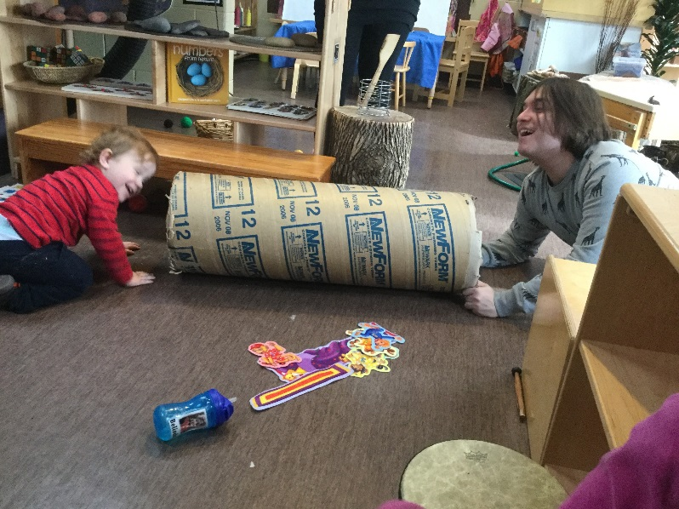
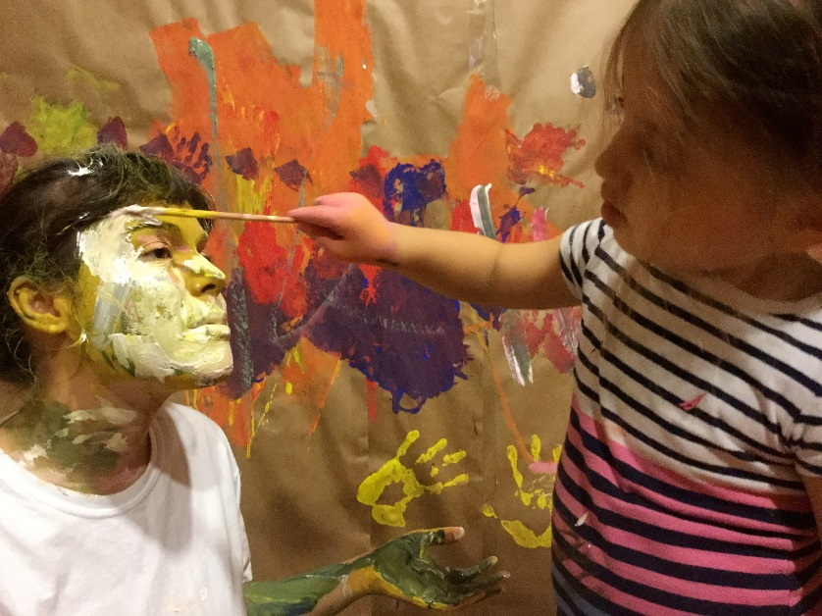
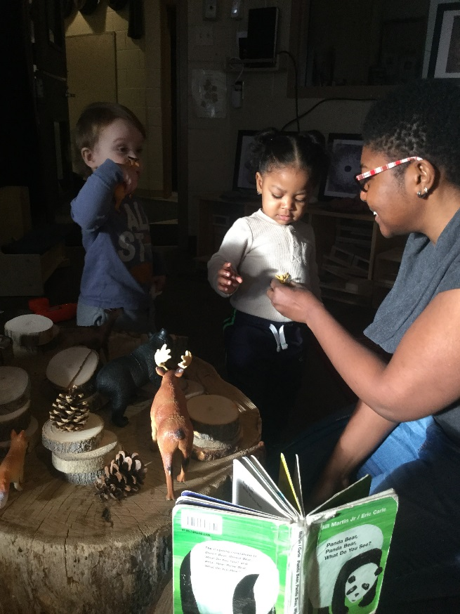
“In sharing enjoyment with a child there is a communication of the fact that as observers and learners we are of the same stuff.”
- Frances Hawkins

Confidentiality of Information
Enrollment forms and all other information documented by the ECE Lab School about your child and family will be accessible only to:
- the Lab School Manager
- other employees as needed to meet the needs of your child
- Toronto Public Health Department
- Children’s Services - City of Toronto
- Program Advisor – Ministry of Education
Our employees will not release information about your child to anyone else without your written consent.

Observations, Photographs and Audio/Video Taping
Enrollment of a child at the ECE Lab School requires that ECE students and faculty will have access to regularly observe them. Students, faculty and/or employees interact with children while others (approved of by the College) observe on video, in class presentations and/or through two-way mirrors and brief visits to the classroom. All classrooms are equipped with closed circuit cameras for use with the School of ECE classes and lab school employees to support student leaning and documentation purposes. Notices will be posted outside classrooms when cameras are recording for student in class observations.
Occasionally, families and children may be audio/video-taped or photographed by ECE students, faculty or employees, for a variety of initiatives approved by the College. These audio/video tapes and/or photographs will be used for research and educational, CD-ROM, and Internet purposes. The ECE program will use these audio/video tapes and/or photographs with ECE students, other educational institutions and organizations as well as government ministries to highlight key aspects of child growth and development, early childhood curriculum and for marketing the College’s ECE Program and Lab Schools.
Information on these initiatives will be available to you from the Lab School Manager.
Participation in these projects is mandatory. The College requires that all families of new children enrolled at the ECE Lab School sign a consent form acknowledging that they understand and agree to allow their child’s participation in such ventures. In addition, family members must sign a consent form indicating that they understand they too may be observed or recorded when they are at the ECE Lab School.

Serious Occurrence Postings
The Ontario Government requires licensed child care centres to post information about serious occurrence that happens at the centre. To support increased transparency and access to information, a “Serious Occurrence Notification Form” will be posted in the ECE Lab School whenever there is a reported serious occurrence. The form will remain posted for 10 business days. The Serious Occurrence Notification Forms are retained on file for two (2) years from the date of the occurrence, and are available to current and prospective families.
A Serious Occurrence could include:
- Serious injury to a child
- Fire or other disaster on site
- A complaint about a Service standard

Legal Obligation to Report Suspected Child Abuse
The ECE Lab School employees are included in Ontario’s Child and Families Services Act legislation’s list of professionals working with children who are legally obliged to report to the Children’s Aid Society when they have reasonable grounds to suspect that a child has been abused or may be in danger. Any employee who has reasonable grounds to suspect that a child is or may be in need of protection must promptly report their suspicion to the Children’s Aid Society.

Medications and Illness
Any child with a medical condition that may require medication to be kept on site or needs accommodations must have an individualized medical plan document completed. These plans will be reviewed and updated annually or as needed. For more information please see the registration package or ask the Lab School Supervisor.

Medication Policy
Children, from time-to-time, need medication. Whenever possible, we ask that you give your child their first dose of any new medication at home. This way you can monitor if your child has any type of reaction to the particular medication.
Medications – Prescription and Non-Prescription Medication*
Legislation requires that the Lab School employees only administer medication under the following conditions:
- medication provided is in the original container supplied by the pharmacist
- the medication container/package is clearly labeled with:
  - the child’s first and last name
  - the name of the medication
  - the expiry date
  - specific, legible instructions for administration
  - storage instructions
- you provide us with written authorization and instructions for its administration including:
  - schedule of times it is to be given
  - dosage to be given
  - the duration of the regimen
  - any additional information that may be required
*Note: The Lab School educators will not administer over-the-counter medications to children without a written prescription from the child’s doctor indicating a need to do so.
We will store all medications in a locked container either in the fridge or cupboard, inaccessible to the children, according to the instructions on the label. Medication is not to be left in your child’s cubby.

Illness Reporting
Please notify the ECE Lab School when your child or another family member is seriously ill with a contagious disease. We will notify families, by way of a letter or poster, of any outbreak of a communicable disease at the Lab School and follow Public Health guidelines and recommendations. Details will be kept in confidence.
Illness and Participation
Toronto Public Health Department sets out certain guidelines for the control of communicable diseases. There is a copy of the current Guidelines and Information on Common Childhood Communicable Diseases posted in your child’s classroom.
The ECE Lab School uses the following criteria to determine if your child cannot participate in the program.
- Does the child have signs or symptoms of conditions listed in the Toronto Public Health document Guidelines and Information on Common Childhood Diseases that demand exclusion?
- Does the child have any of the following conditions that may indicate a contagious disease or serious illness?
  - Fever of 38ºC and/or symptoms indicative of illness including but not limited to:
- unusual drowsiness
- emotional
- persistent or excessive crying
- wheezing
- uncontrolled coughing
- difficulty breathing
- unable to participate in the program
- complaining of severe pain
If Your Child Becomes Ill
If a child develops symptoms of an illness while at Lab School the employees and Manager will assess the child’s condition. They will determine if the child can remain at the Lab School or if they is too ill to participate.
An employee or the Lab School Manager will notify you of your child’s condition.
If the child is too ill to stay with the group of children, we will provide a place in the classroom for your child away from the group until you arrive.

Health Policy
The prevention of illness is the foundation of our health policy. By ensuring that all families follow our health policies, we are ensuring the best possible environment for each child. The Child Care and Early Years Act, 2014 stipulates that, prior to admission, each child must be immunized as recommended by the local Medical Officer of Health and must also submit medical certificate confirming they have had a medical assessment.
Children who are ill must not be brought to the ECE Lab School as the day is too demanding for a sick child. Families are asked to find alternative care for a child who is ill or who has a contagious disease. A child who is not well is more prone to infection and communicable disease. Young children are still building their immunities. Families must keep a child at home if the child has a fever, is vomiting, diarrhea or any contagious disease.
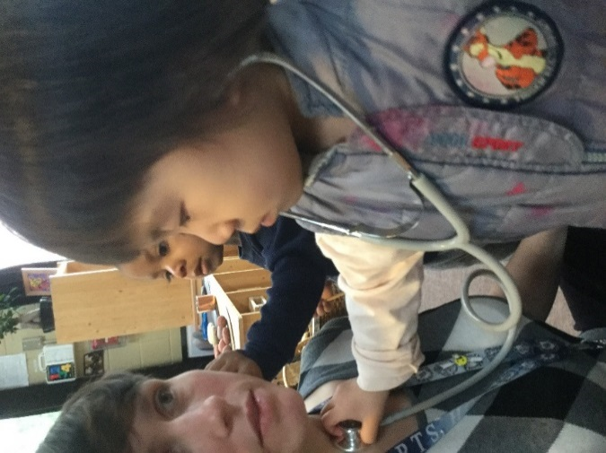
The employees will carry out a regular health inspection of your child. As requested by Toronto Public Health, the teacher has the right to refuse admittance if your child appears sick. If the child has been admitted and is showing signs of illness that may affect the health of others, you will be contacted immediately and will be required to pick up their child as soon as possible. They will be cared for in the program until the family member or designated alternate arrives.
Tiredness is also a health concern. A tired child is more prone to infection and communicable diseases. Please ensure that your child has adequate rest and a reasonable length of day at the centre.
The Child Care and Early Years Act, 2014 requires that the children play outdoors every day for two hours, weather permitting. If your child is too ill to participate in the outdoor part of the program, we suggest that alternative care is arranged.

Contagious Disease
Any child who shows signs of the following contagious illnesses must be kept home, or picked up if symptoms present while at the ECE Lab School as soon as possible and may return with a doctor’s consent.

Diarrhea
Diarrhea is a sign of infection or irritation in the digestive tract. If a child is suffering from diarrhea (Bowel movements that appear watery or greenish and are more frequent than usual) they must be kept at home. The child will be re-admitted to the ECE Lab School after they are clear of symptoms for 48 hours. In periods of outbreak, the amount of time clear of symptoms may be extended.

Rubella
Signs and symptoms:
- Low grade fever (37.6c), headache, cough, red eyes, runny nose and swollen glands at the back of the neck. The rash appears as mottled or tiny raised spots which spread from the face and the neck, to the entire body over 12-24 hours.
The disease is most communicable for 7 days before and 4 days after the rash appears. A child may return to school 5 days after the rash appeared with a doctor’s note, which states that the child is no longer able to transmit the disease to others.

Mumps
Sign and symptoms:
- Tender swelling in front and below the ear. The swelling begins on one side and then may occur on the other side within 2-3 days.
- Fever and vomiting may occur
The child will be re-admitted as soon as the swelling around the ear goes down. A doctor’s consent for returning to the ECE Lab School is required.

Impetigo
Signs and symptoms:
- The appearance of small fluid filled blisters leading to brownish crusts especially around the mouth and nose but may occur anywhere on the body
A child may return to the ECE Lab School when all sores have dried up. A doctor’s note is required.

Hand-Foot-and-Mouth-Disease
Hand-foot-and-mouth disease is a viral infection that most often affects young children, but can occur at any age. It may cause fever, headache, a sore throat and mouth, loss of appetite, lack of energy and a characteristic rash. Red spots, often with small blisters on top, appear on the hands and feet and sometimes elsewhere on the body. Small, painful ulcers may also develop in the mouth. This illness usually lasts for 7 to 10 days. Because a virus causes it, antibiotics do not help. Outbreaks of hand-foot-and-mouth disease are most likely to occur in the summer and fall. This disease spreads from person to person through contact with the virus present in an infected person’s saliva or stool. This virus may remain in the stool for 4 weeks after the onset of illness.
What to do:
- Child is to be seen by a doctor for diagnosis and treatment.
- Reinforce proper hand-hygiene and diaper-changing routines.
- Clean and disinfect any items soiled with nasal and/or throat discharges.
Children with hand-foot-and-mouth disease may return to the ECE Lab School when all the spots have crusted over.

Chicken Pox
Signs and symptoms:
- A fever and headache followed by a rash, which is described as crops of blisters turning into scabs which appear over several days. The child experiences itching for about 4 days.
Children may return to the ECE Lab School when all the blisters are crusted over.

Conjunctivitis (Pink Eye)
Signs and symptoms:
- Initially the eyes may be red swollen and later there is a copious discharge of pus.
- Eyes itch and swell but there is no pain.
- One or both eyes may be affected.
Any child who shows signs of this contagious illness must be picked up from the ECE Lab School as soon as possible and may not return until the whites of the eyes are clear and no crusting or discharge are evident.

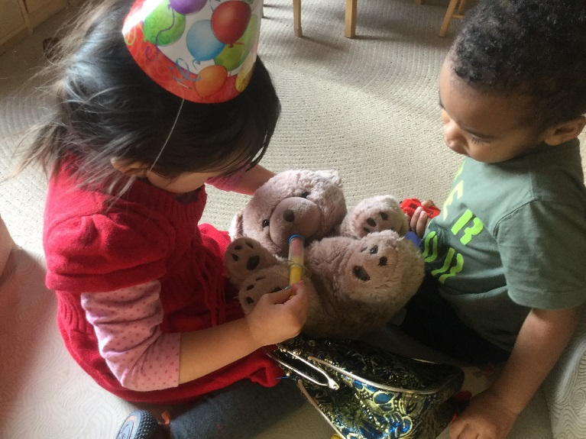
Fever
Children who have developed a temperature at or above 38.5c are to be picked up from the ECE Lab School as soon as possible. A family member will be notified and asked to pick up their child as soon as possible. Children should remain at home for 24 hours after their fever has cleared without the aid of medication and must be well before returning to the ECE Lab School. (i.e. they must be able to participate fully in the indoor and outdoor daily program)

Vomiting
Vomiting is a sign of communicable disease or stomach irritation. Children should remain at home for 24 hours after vomiting has stopped. The child must be well before returning to the ECE Lab School. In periods of outbreak, the amount of time without symptoms may be extended to 48 hours or longer.
Head Lice
Head lice can be a very time consuming and cumbersome issue to contain, particularly with children playing so closely with one another. Due to the nature of this pest, children that appear to have head lice or eggs will be sent home as soon as lice or the eggs are detected. Families are asked to start treatment for the lice immediately and follow guidelines as prescribed to eliminate the lice in bedding, children’s belongings etc. Educators will re-evaluate upon re-admission in order to stop the spread of this pest.

Food Allergies and Restrictions
We can accommodate most children who have food allergies, sensitivities or food restrictions due to religion or reasons of conscience. The ECE Lab School will follow families’ written instructions for food restrictions. If we cannot provide an acceptable alternative, we will ask you to send alternate food for your child each day.
The Child Care and Early Years Act, 2014 outlines specific requirements regarding the total amount from each food group we must provide to children. In order for the ECE Lab School eliminate or severely restrict any one of the major food groups from your child’s meals for an extended period of time, you must meet with the Lab School Manager to discuss a strategy for ensuring your child’s nutritional requirements are met.

Anaphylactic Policy
Purpose of the Policy and Procedures
Seneca College ECE Lab School is committed to taking a pro-active position regarding the prevention of anaphylaxis. The purpose of the policy is to provide a process for dealing with anaphylaxis in the centre.
Definition of Anaphylaxis
Anaphylaxis is a severe allergic reaction that can be fatal, resulting in circulatory collapse or shock. The allergy may be related to food, insect stings, medicine, latex, etc.

Strategy to Reduce Risk of Exposure
- The Lab School is a Peanut and Tree Nut (ie. Almonds, walnuts, cashews etc) free environment.
- Foods with “May contain” nut warnings will not be served
- All labels will be read by an employee prior to serving
- Food suppliers will be notified of all life threatening allergies in the Lab School. List of allergies will be revised as necessary.
- All children and educators will wash hands before and after handling food
- All surfaces will be cleaned with a cleaning solution as approved by public health prior to and after preparing and serving foods
- All cleaning supplies, medicines and any other products that may be of danger and /or commonly produce allergic reactions will be stored away
- Extra special supervision of children with anaphylactic allergies during eating
- Epi-Pens and Emergency Medications prescribed by a doctor will be located in the emergency bag belonging to the child’s classroom, and will accompany the child everywhere. The bag will be kept out of the children’s reach.
Any child with an anaphylactic allergy must have a completed emergency medical plan document including a signature from a physician. These plans will be reviewed and updated annually or as needed. For more information please see the registration package or ask the Lab School Supervisor.

Food from Home
In order to reduce the risk of exposure to allergy and potential life threatening anaphylactic reactions the Seneca ECE Lab School will adhere to a strict policy on outside food. We have serval children with life threating allergies, and controlling outside food is necessary to ensure everyone’s safety.
Please note that effectively immediately the Lab School will not permit outside food. If children are eating food from home on their way to the Lab School, please ensure they are finished before entering the building, and clean their hands upon arrival. The exception to this is in a sealed/ labeled and dated container that must be stored in the refrigerator in the Lab School Kitchen. Anything in the container must be peanut and tree nut free.
For birthdays and special occasions, please speak with your child’s educator about alternatives to birthday cakes etc. During Lab School Potlucks, please avoid dishes that include any allergens listed on the sign up board, and also supervise what your children are eating as we cannot guarantee that everything at a potluck will be allergen free.
Please sign off on the acknowledgement statement that you fully understand our new policy that outside food is no longer permitted on the premises. Failure to comply with this policy could result in your family being withdrawn from the program. This policy in put into place to ensure the safety and well-being of those children under our care who are susceptible to life threating anaphylactic shock. Thank you for your cooperation.
NOTE: We have children in the program who have anaphylactic reactions to peanuts, tree nuts (ie. walnuts, almonds, cashews, etc.) and other foods. In people with severe allergy, an amount less than 1/1000 of a peanut can cause a life-threatening reaction. As cleaning away all the vestiges of peanut butter is nearly impossible, we ask your cooperation in not bringing peanut butter or any nut products into the ECE Lab School. This includes but is not limited to whole nuts, nut butters, candies and baked goods containing or which may contain nuts.

Birthdays and Celebrations
Seneca College ECE Lab School understands that protecting children with life threatening food allergies means imposing some limitations on the foods that other children and educator can bring into the ECE Lab School.
We ask that you discuss this ahead of time with an educator if you are planning to bring in any food for the class to enjoy. (Peanut/nut allergies, other allergies, food restrictions, and sugar intake are concerns for some of our families).
Responsibilities of all families of children at the ECE Lab School:
- Respond co-operatively to requests from the ECE Lab School to eliminate allergens from all foods sent to the ECE Lab School (snacks, special occasions, treats, etc.)
- Ask for permission from an ECE Lab School employee prior to giving any food products to any children in the program.
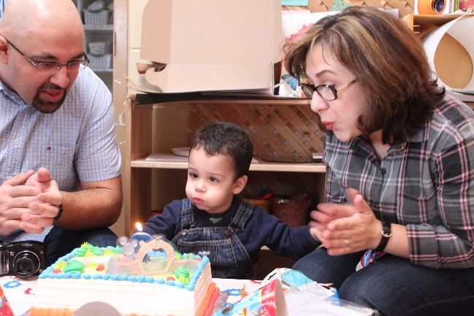
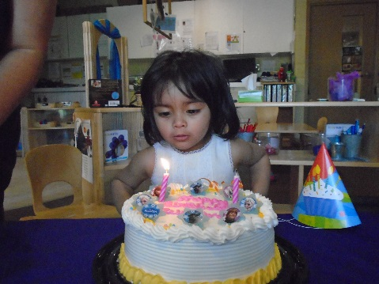
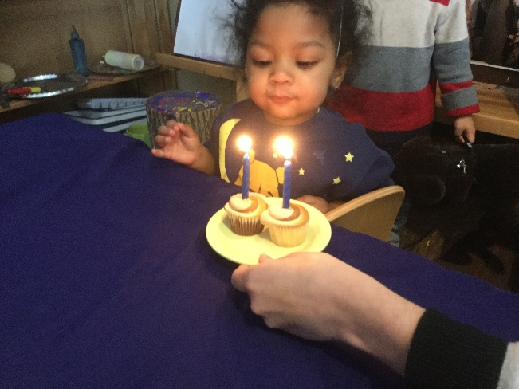
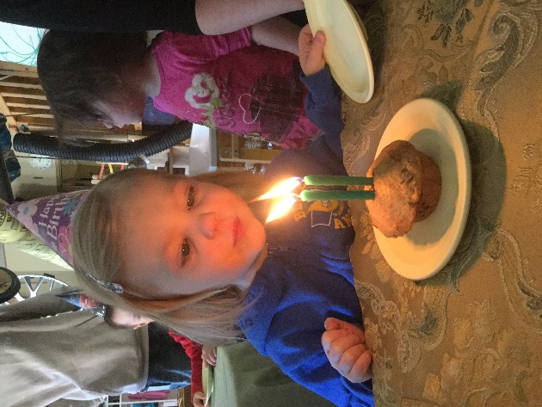

Family Issues and Concerns Policy and Procedures
Families are encouraged to take an active role in the Seneca ECE Lab School and regularly discuss what their child(ren) are experiencing with our program. As supported by our program statement, we support positive and responsive interactions among the children, families, child care providers and employees, and foster the engagement of and ongoing communication with families about the program and their children. Our employees are available to engage families in conversations and support a positive experience during every interaction.
All issues and concerns raised by families are taken seriously by the Seneca Lab School and will be addressed. Every effort will be made to address and resolve issues and concerns to the satisfaction of all parties and as quickly as possible.
Issues/concerns may be brought forward verbally or in writing. Responses and outcomes will be provided verbally, or in writing upon request. The level of detail provided to the family will respect and maintain the confidentiality of all parties involved.
An initial response to an issue or concern will be provided to families within 1 business day. The person who raised the issue/concern will be kept informed throughout the resolution process.
Investigations of issues and concerns will be fair, impartial and respectful to parties involved.

Confidentiality
Every issue and concern will be treated confidentially and every effort will be made to protect the privacy of families, children, employees, students and volunteers, except when information must be disclosed for legal reasons (e.g. to the Ministry of Education, College of Early Childhood Educators, law enforcement authorities or a Children’s Aid Society).

Conduct
The Seneca ECE Lab School maintains high standards for positive interaction, communication and role-modeling for children. Harassment and discrimination will therefore not be tolerated from any party.
If at any point a family, employee, student or volunteer feels uncomfortable, threatened, abused or belittled, they may immediately end the conversation and report the situation to the supervisor and/or licensee.

Concerns about the Suspected Abuse or Neglect of a child
Everyone, including members of the public and professionals who work closely with children, is required by law to report suspected cases of child abuse or neglect.
If a family expresses concerns that a child is being abused or neglected, the family will be advised to contact the local Children’s Aid Society (CAS) directly.
Persons who become aware of such concerns are also responsible for reporting this information to CAS as per the “Duty to Report” requirement under the Child and Family Services Act.
For more information, visit http://www.children.gov.on.ca/htdocs/English/childrensaid/reportingabuse/index.aspx
Procedures
Program Room Related Concerns (eg. schedule, sleep arrangements, toilet training, indoor/outdoor program activities, feeding arrangements, etc.): When families have concerns related to the program room, families should first raise the issue or concern to the educator directly in a private conversation away from the children. Educators may ask the family to join them in the employee lounge when appropriate. If the family or educator feels the issue cannot be resolved, they can bring it to the Lab School manager for consultation and support.
General, Centre or Operations related Concerns (E.g: child care fees, hours of operation, staffing, waiting lists, menus, etc.): When families have general concerns related to the operations of the Lab School, families should first raise the issue or concern to the Lab School manager directly in a private conversation away from the children, via phone call or email. The Lab School Manager may ask the family to set up a time for a meeting to address their concerns within 1-3 business days of when the concern was raised.
Employee, supervisor and or licensee related: When families have concerns related to an employee or the supervisor of the Lab School, families should first raise the issue or concern to the individual directly if they feel comfortable in a private way away from the children. If the family doesn’t feel comfortable approaching the individual they may they may discuss their concerns with Lab School manager directly in a private conversation away from the children, via phone call or email. The Lab School Manager may ask the family to set up a time for a meeting to address their concerns within 1-3 business days of when the concern was raised. All issues or concerns about the conduct of employee, etc. that puts a child’s health, safety and well-being at risk should be reported to the supervisor as soon as families become aware of the situation. Should a family have a concern related to the Lab School Supervisor and they do not feel comfortable approaching them, the family may follow the steps for escalating the issue/concern.
Other Families
If a family has concerns regarding another family or child, they should address the concerns with the educators and /or supervisor in a private conversation away from the children.
Student/Volunteer related: When families have concerns related to a student or volunteer, families should first raise the issue or concern to the educator responsible for supervising the student/volunteer directly in a private conversation away from the children. Educators may ask the family to join them in the employee lounge when appropriate. If the family feels the issue cannot be resolved, they can bring it to the Lab School manager. All issues or concerns about the conduct of students and/or volunteers that puts a child’s health, safety and well-being at risk should be reported to the supervisor as soon as families become aware of the situation. When appropriate the field placement liaison will be notified.
Steps for Employees and/or Licensee in responding to issues/concerns
- Address the issue/concern at the time it is raised or arrange for a meeting with the family within 1-3 business days or as soon as reasonably possible to discuss their concerns.
- Document the issues/concerns in detail. The documentation should include:
  - The date and time the issue/concern was received
  - The name of the person reporting the issue/concern
  - The details of the issue/concern
  - Any steps taken to resolve the issue/concern and/or information given to the family regarding next steps or referral.
  - Provide contact information for the appropriate person if the person being notified is unable to address the matter.
  - Ensure the investigation of the issue/concern is initiated by the appropriate party within 1-3 business days or as soon as reasonably possible thereafter. Document reasons for delays in writing.
  - Provide a resolution or outcome to the family who raised the issue/concern.

Escalation of Issues or Concerns
Where families are not satisfied with the response or outcome of an issue or concern, they may escalate the issue or concern verbally or in writing to the academic chair, Mary Fisher (contact information can be found below).
Issues/concerns related to compliance with requirements set out in the Child Care and Early Years Act., 2014 and Ontario Regulation 137/15 should be reported to the Ministry of Education’s Child Care Quality Assurance and Licensing Branch.
Issues/concerns may also be reported to other relevant regulatory bodies (e.g. local public health department, police department, Ministry of Environment, Ministry of Labour, fire department, College of Early Childhood Educators where appropriate.

Contacts:
Academic Chair: Mary Fisher
mary.Fisher@senecacollege.ca
416-491-5050
Ext.22040 (Newnham campus)
Ext. 55327 (King Campus)
Program Advisor (Ministry of Education): Odelia Tsang
Odelia.tsang@ontario.ca
416-325-5970
District Consultant (Toronto, Children’s Services): Ryan Vender
ryan.vender@toronto.ca
416-392-3321
Ministry of Education, Licensed Child Care Help Desk:
1-877-510-5333 or childcare_ontario@ontario.ca

Issues and complaints can be brought forward to employee and or supervisor in a private and discreet manner. When appropriate the families can request a private area in the office or employee lounge to have an initial discussion regarding the issue or concern with the employee or supervisor. The educator and family can determine a resolution and appropriate next steps, request a follow up meeting and given a time line in regards to the resolution of the matter if not immediate. If the families feel that the concern was not handled appropriately or in a timely manner they may choose to inquire further with the Academic Chair, Mary Fisher and/or the District Consultant, Ryan Vender and/or any other appropriate governing agency.

Withdrawal Policy
At the ECE Lab School, we strive to meet the diverse needs of our children and families. On occasion, the families or the Lab School may feel that our learning environment may not be a fit in regards to the family’s needs or philosophy. When this occurs, families are encouraged to engage in conversation with the Lab School manager about their concerns (please refer to the Family Issues and Concerns Policy and Procedures for details). If the family decides to withdrawal from the program we require a written notice of withdrawal. In order for the families deposit to be applied to their final invoice, the family must give the written notice of withdrawal a minimum of two weeks prior to the child’s last day. During the child’s first two weeks in the program, families may give notice of withdrawal without penalty.
The two weeks written notice is also required for families transferring to alternate care or whose child is transitioning into kindergarten in order for the family’s deposit to be applied to their final invoice. If a family chooses to give less than two weeks’ notice for any reason, they forfeit their deposit.
Seneca College ECE Lab School is committed to delivering high quality care to children and their families. However, there are times when we are unable to meet the needs of a child. We reserves the right to terminate the family’s contract should the program be unable to meet a child’s needs. A written notice of withdrawal will be provided to the family a minimum of two (2) weeks prior to the suggested last day. If the family has not yet paid their final invoice, their deposit will be applied to it and the balance will be the families’ responsibility to pay upon the final day registered. If the family has paid their final invoice, their deposit will be refunded via the method of payment use at the time of deposit.
Once enrolled, the Lab School will work with the family and additional support services, if needed, to ensure that a child’s extra support needs are met. However, when all possible avenues have been exhausted, it may be determined that the program is unable to meet the needs of the child. This decision will be made in collaboration with the family, the Lab School Manager, the Children’s Services Consultant and the Resource Educator. The ECE Lab School Administration will make the final decision.
The following protocol will be followed:
- Behaviour is documented over a period of time by educators
  - Educators and families will communicate daily regarding the child’s behavior.
  - Families will provide the Lab School with pertinent information that may help educators support the child’s development
- The educators will submit a written formal report to the Lab School Manager.
- The Lab School Manager and educators will meet to discuss the documented concerns and strategies.
- A trial period for the suggested strategies is established.
- On completion of the trial period, the educators and the Lab School Manager will meet to discuss the documented observations of the behaviour and the strategies implemented. If additional support is required, a meeting will be arranged with the family, educators and Lab School Manager.
The following steps will then be followed:
    - Identify the concerns and possible reasons
    - Discuss implications for the child or other children involved
    - Discuss ways for involving community resources
- Contact community resource and discuss behavior, strategy implemented and review the results. The results are again committed in writing and signed by all parties.
- If the lab school employees and families have determined that the child’s needs cannot be met at the lab school, a recommendation of withdrawal will be forwarded to the family as well as an invitation to attend a meeting with the Academic Chair, Lab School Manager and educators, in order to put their position forward.
- If the family does not attend the meeting, or if after attending, the Academic Chair and lab school manager decide that it is the best interest of the child that they be withdrawn from the program, written notice of withdrawal will be given to families effective two weeks from the date of the scheduled meeting.
- Children’s Services Consultant will be notified if a child is asked to withdraw from our program and the families will be advised of various community supports and/or other services available to them.

In extreme circumstances, where the Lab School requires a family to immediately be withdrawn from the program, the Lab School Manager, will consult with the District Consultant on recommendations for final invoices and return of deposits paid.

Code of Conduct: Belonging, Engagement, Expression and Well-Being
At the Lab School we strive to create authentic relationships with the families in our community based first and foremost on trust and respect. The importance we place on the bond educators cultivate with families affirms that we make relationships a priority; communicating effectively and providing support which builds a strong foundation of trust. Our goal is to create a sense of belonging, engagement, expression and well-being with all families. They, in turn become part of the program, adding and enriching learning for all.
The following expectations are intended as a guide to maintaining the atmosphere at the ECE Lab School as happy, comfortable, and safe place to be for every member of our community.
Our community shall:
- Show respect for all individuals through their behaviour and words.
- Be courteous
- All employees and students at Seneca College have a right to work and study in an environment that asserts the personal worth and dignity of each individual. In order to achieve this objective, Seneca College will not tolerate any form of violence, discrimination and/or harassment in its employment, educational, accommodation or business dealings. Any instances of inappropriate behaviour on the part of any college employee, student, client or visitor will be referred to the appropriate College official for review.
- Conduct them self in a manner which allows each member of our community to feel safe from verbal and physical abuse.
- Resolve conflict in a peaceful manner.
- Respect the building and equipment as well as the personal property of all.
Please note that all employees are to be treated in a professional and courteous manner. Employees are providing quality programming for your child and will not accept treatment that is disrespectful. Please deal with discrepancies in private (away from the children and other adults). Under no circumstances will any form of abuse be tolerated towards an employee. Any such action will result in immediate withdrawal from the ECE Lab School.
Seneca College ECE Lab School reserves the right to terminate a family’s contract on the following grounds:
- Non-payment of fees (two months in arrears)
- Contravention of the “Code of Conduct”
*See Withdrawal Policy on page 49
We welcome you and your family into our ECE Lab School community and look forward to the journey of learning ahead. As a valued member of our community we look forward to cultivating an authentic relationship, getting to know your family and building a connection that can last a lifetime.

Phone Numbers and Contact Information

Seneca College Phone Number: (416) 491-5050
To reach the Lab School, dial the Seneca College main number and one of the following extensions:
Tanya Farzaneh (Lab School Manager): Extension 24710
Email: tanya.farzaneh@senecacollege.ca

Toddler East-H1909: Extension 24713

Toddler North-H1911: Extension 24712

Preschool South-H1907: Extension 24714

Preschool West-H1904: Extension 24715

Playground: Extension 24717

Messing About Room: 24718
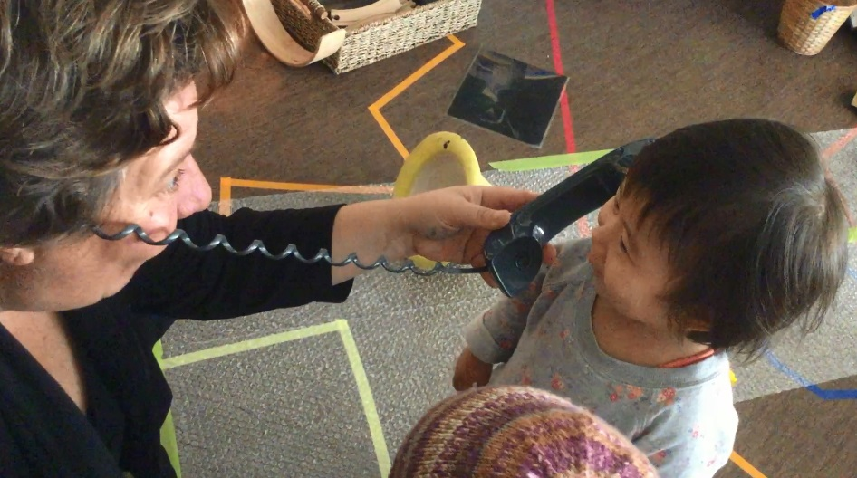
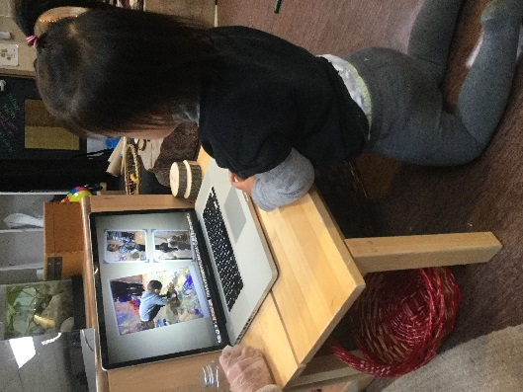
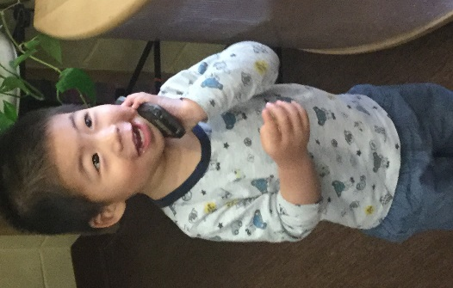

© 2017 Seneca College of Applied Arts and Technology ECE Lab School All Rights Reserved
Revised January, 2019

